**CCMS**

**Document v 1.4**

**Version Date: 14/03/2016**

**Written by**

**Mohammad Yasir Arafat**

**Programmer, Convince Computer Ltd.**

**CCMS**

**Document Information**

Document Name: CCMS_documentation.docx

Current Version: 1.4

Current Version Date: 14 March 2016

Author: **Mohammad Yasir Arafat**

Information Security Classification: **INTERNAL**

**Revision History**

|  |  |  |  |  |
| --- | --- | --- | --- | --- |
| **Version** | **Date** | **Contributors** | **Reviewer** | **Comments** |
| 1.0 | 07/03/2016 | Mohammad Yasir Arafat |  | Document Created |
| 1.1 | 09/03/2016 | Mohammad Yasir Arafat |  | Updated with details of security portion |
| 1.2 | 10/03/2016 | Mohammad Yasir Arafat |  | Updated with description of administrative menus |
| 1.3 | 13/03/2016 | Mohammad Yasir Arafat |  | Updated with cover page, document information, references |
| 1.4 | 14/03/2016 | Mohammad Yasir Arafat |  | Updated with index(Contents), revision history |

**Contents**

**1 Introduction………………………………………………………………………………………………………………………..…4**

**2 Purpose and Objective……………………………………………………………………………………………………….....5**

**3 References……………………………………………………………………………………………………………………………. 5**

**4 Description of the Main Menus……………………………………………………………………………………………..6**

**4.1 File……………………………………………………………………………………………………………………………………….. 6**

**4.1.1 Pending Authorization List……………………………………………………………………………………………………. 6**

**4.1.2 Authorize an Item…………………………………………………………………………………………………………………. 9**

**4.2 Maintenance………………………………………………………………………………………………………………………. 11**

**4.2.1 Client…………………………………………………………………………………………………………………………………… 11**

**4.2.1.1 Adding a Client………………………………………………………………………………………………………………… 12**

**4.2.1.2 View all Clients………………………………………………………………………………………………………………… 18**

**4.2.1.3 Edit a Client……………………………………………………………………………………………………………………… 19**

**4.2.1.4 Delete a Client…………………………………………………………………………………………………………………. 21**

**4.2.2 Branch Upload…………………………………………………………………………………………………………………….. 24**

**4.2.2.1 Branch Upload File Format ….…………………………………………………………………………………………... 25**

**4.2 Deposit……………………………………………………………………………………………………………………………….. 26**

**4.2.1 Deposit Schedule………………………………………………………………………………………………………………… 26**

**4.2.1.1 Adding a Deposit Schedule………………………………………………………………………………………………..26**

**4.2.1.2 Edit Deposit Schedule………………………………………………………………………………………………………. 45**

**4.2.1.3 Missing CitiCash/CitiSpeed Detail…………………………………………………………………………………….. 51**

**4.2.2 CitiCash Detail…………………………………………………………………………………………………………………….. 52Introduction**

CCMS (Citi Cash Management System) is a software by which Citi Bank, NA manages their cash related operations, keep track of their software user activity, authorize transactions, generate some files and reports, view and manipulate information.

The software has eight main menus:

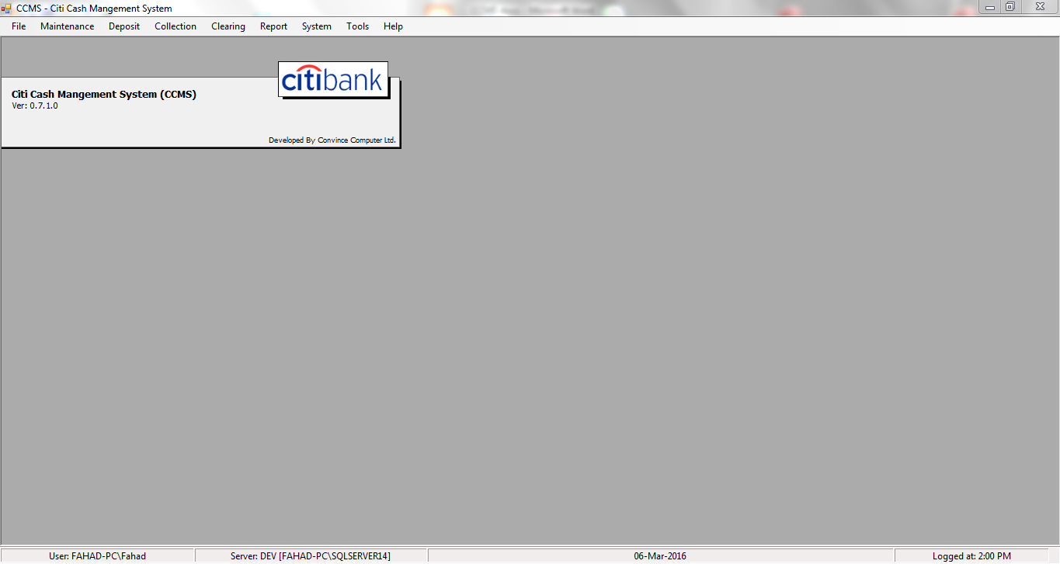

1. File
2. Maintenance
3. Deposit
4. Collection
5. Clearing
6. Report
7. System
8. Tools

**Purpose and Objective**

1. Provide information on how CCMS works
2. Provide business logic, code snippets, and data structure
3. Provide step by step guideline to the functionalities with necessary screen shots
4. Provide reference information

**References**

|  |  |
| --- | --- |
| **Document Name** | **Description** |
| [CCMS_CTR Security.docx](CCMS_CTR%20Security.docx) | Describes the coding details of CCMS and CTR security with code snippets. |

**Description of the Main Menus**

1. **File**: In this menu, there are there submenus: a) Pending Unauthorized List, b) Log Out, c) Exit

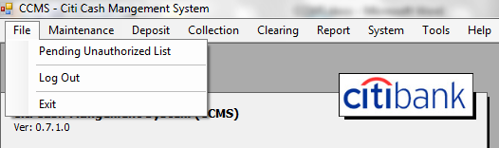

1.a) Pending Unauthorized List: If you click on this menu, a form will appear where you will find a button named “Load List” at top right corner.

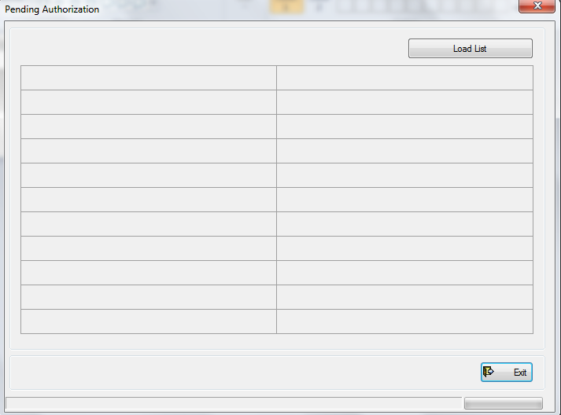

Click on the “Load List” button to load the unauthorized actions of the whole software. A list will appear where you can see all unauthorized actions at a glance.

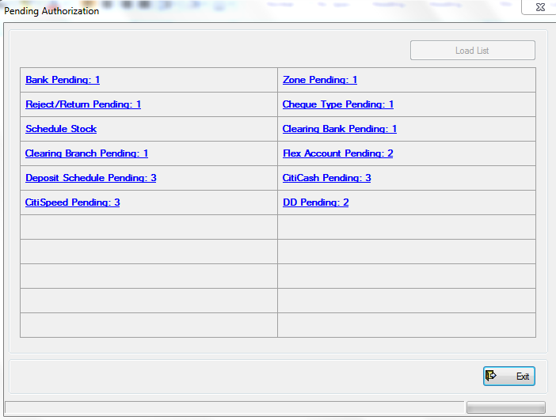

Click on any unauthorized action to see the detail of that particular action. Suppose, there is a Bank inputted by a user which is pending for authorization. You will see a link named “Bank Pending: 1” in blue text. Click on that link. You will be redirected to “Bank Summary” form where you will find an option named “Unauthorized”.

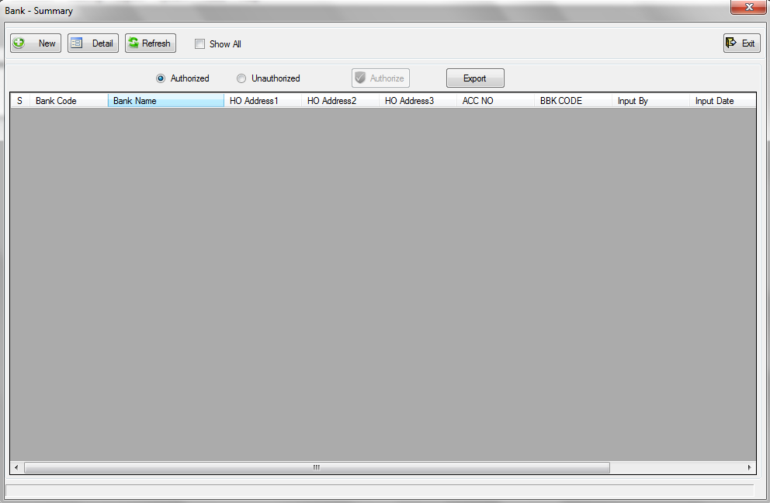

Click on the “Unauthorized” option. The unauthorized list of Banks will be shown to you.

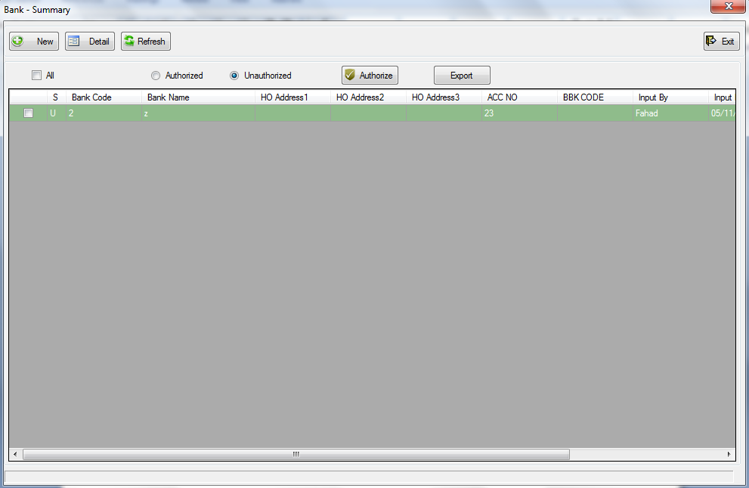

To authorize a Bank without changing the existing information of the Bank, just select the Bank by clicking on the checkbox at the beginning of the Bank row, and click on the “Authorize” button.

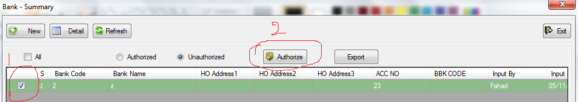

You can select all the unauthorized banks by selecting the “All” checkbox above the unauthorized list.

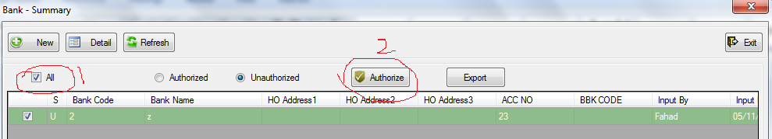

To make a change in the existing information of a particular bank, double click on the Bank row, or click the “Detail” button after selecting the row. A form named “Bank Detail” will appear.

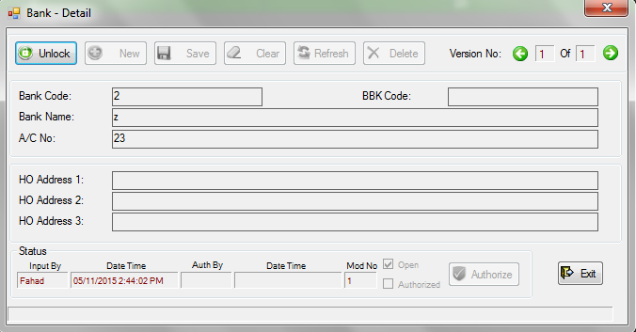

To edit the bank information, click on the “Unlock” button at the top left corner. The Bank information will be editable if you have enough permission to edit the Bank. The “Authorize” button at bottom will be enabled if you have permission to authorize the bank.

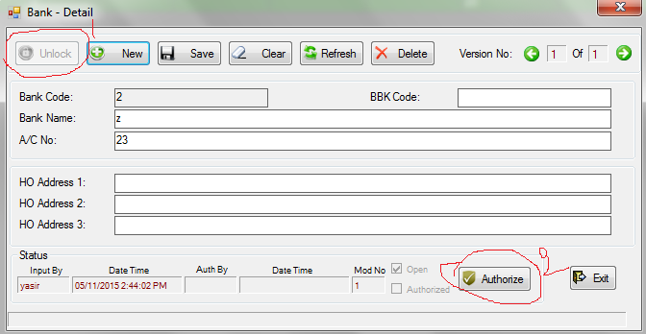

Remember that if you make any change of an entity, you will not be able to authorize it.

After clicking the “Authorize” button, you will be asked to confirm the authorization. If you click yes, the Bank will be authorized if you are an authorized user to authorize.

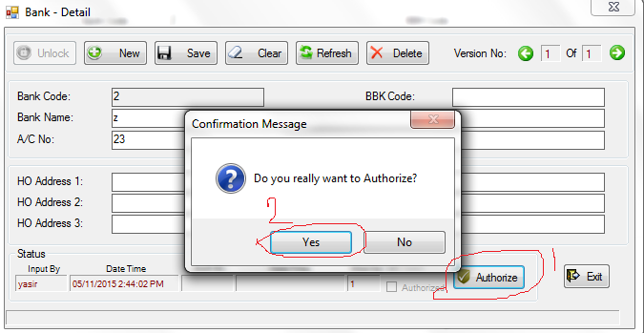

Once a data is authorized, it will be available to the whole software until it is changed or deleted. If it is changed by any kind of manipulation, it needs to be re-authorized.

We have discussed the authorization process of a Bank in our above example; the authorization process of any entity is same.

N.B: Deletion also needs authorization.

1. **Maintenance:**

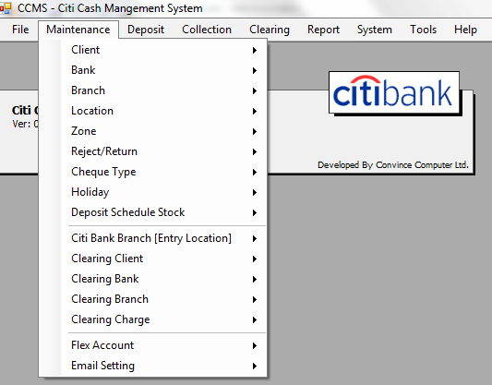

There are 16 menus in maintenance. Each has at least 2 common sub-menus: 1.”Detail” and 2. “Summary”. The ” Branch” and the “Clearing Branch” menu have an extra submenu named “Upload”.

If you go to Maintenance->Client, you will see 2 options for Client: 1. Detail, 2. Summary

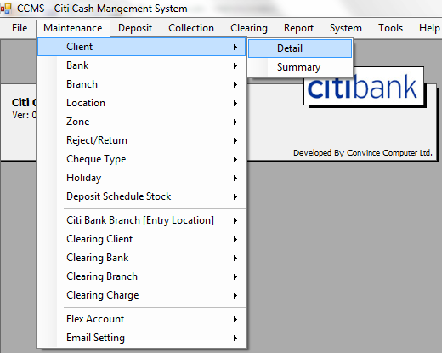

If you click on the “Detail“, a form named “Client – Detail“ will appear.

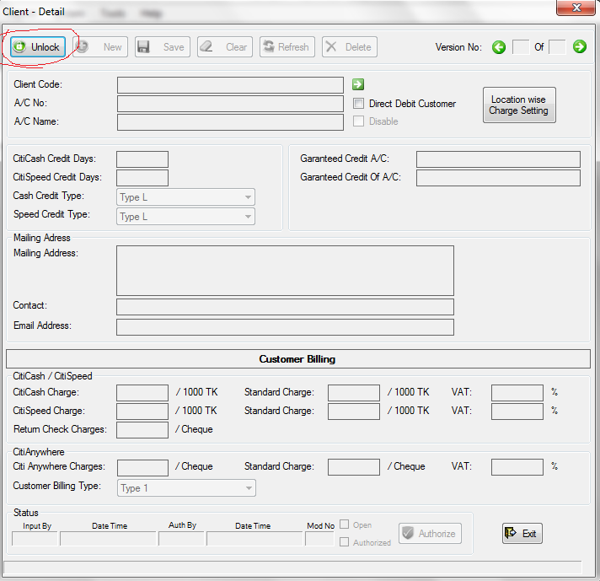

Click on the “Unlock” button. The “New” button will be enabled if you have enough permission to unlock the form i.e. enough permission to insert a new client.

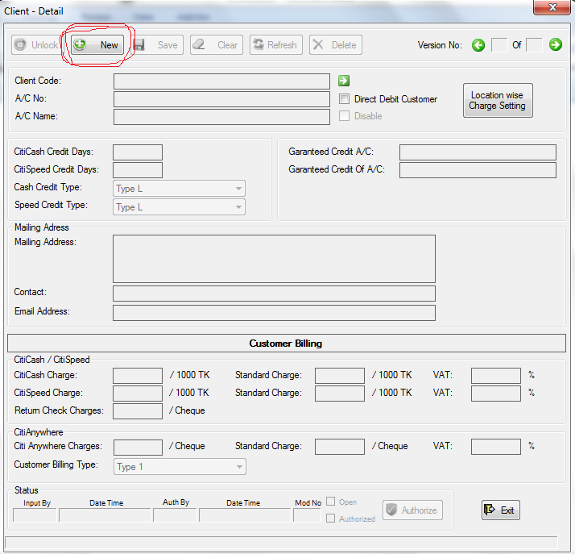

Click on the “New” button to insert a new client. All the fields, buttons, and options needed to insert a new client will be enabled. Once you have finished giving the necessary information of the new client, click on the save button to insert this client to the system.

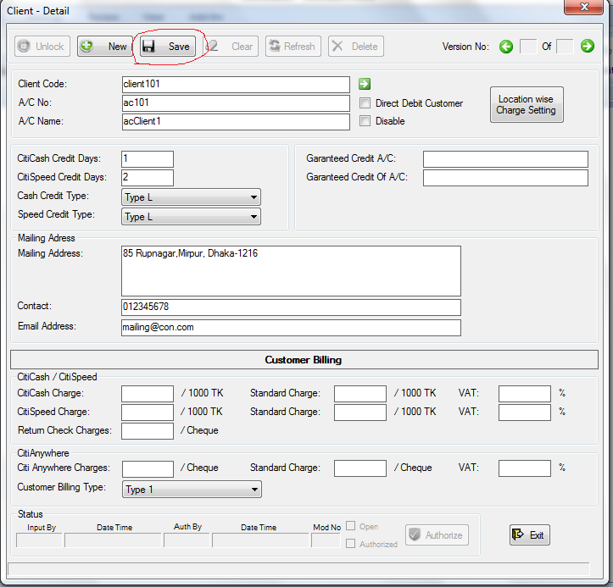

You will be asked for confirmation after clicking the save button. Click “Yes” if you are sure.

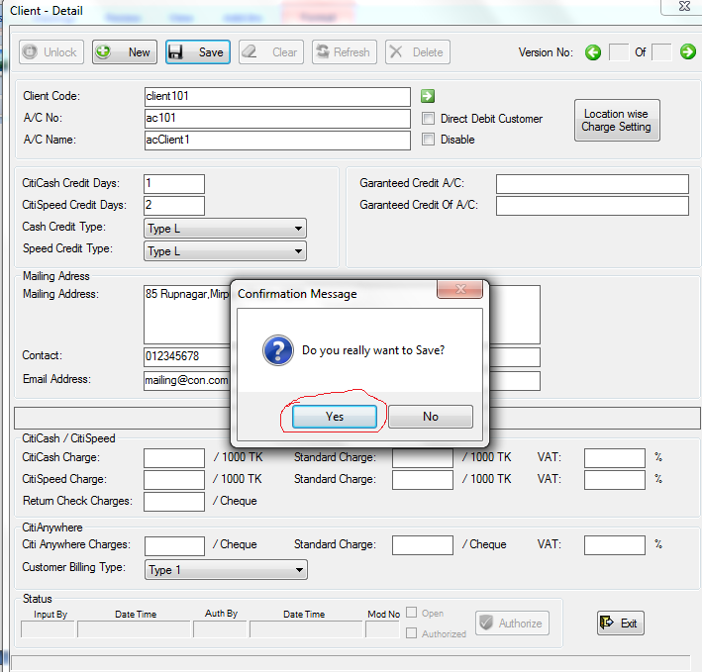

A post saving message will be shown at the bottom.

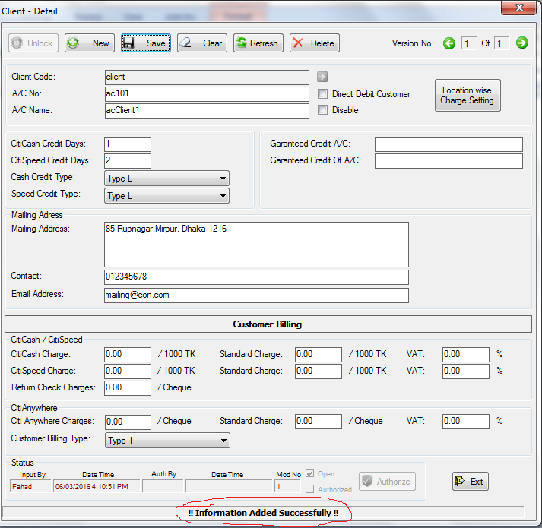

If the data you have entered can be saved, you will see: “!! Information Added Successfully!!” at the bottom. To enter another client, click on the “New” button and follow the same process. After you have finished inserting client, click on the “Exit” button, or simply close the form to go to the main menu. The newly inserted data will remain pending for authorization. To view the status of this new data, we can either follow the process of Section 1. a) or we can directly go to Maintenance->Client->Summary .

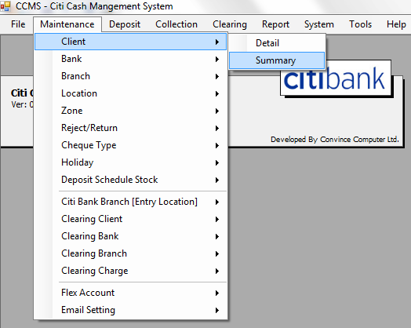

After clicking on the “Summary”, the “Client – Summary” form will appear. If the newly inserted data is authorized, then we will see them in the default “Authorized” list.

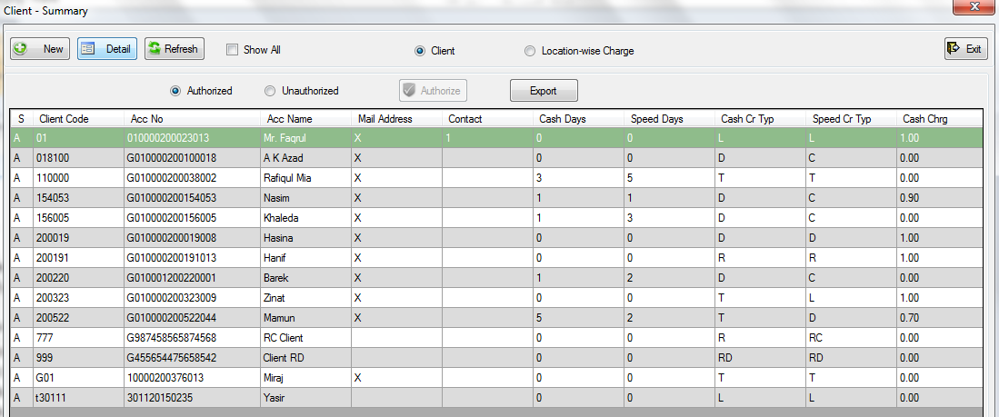

If not, that means they are not authorized yet. We will find them in the “Unauthorized” list. Just click on the “Unauthorized” option to find them.

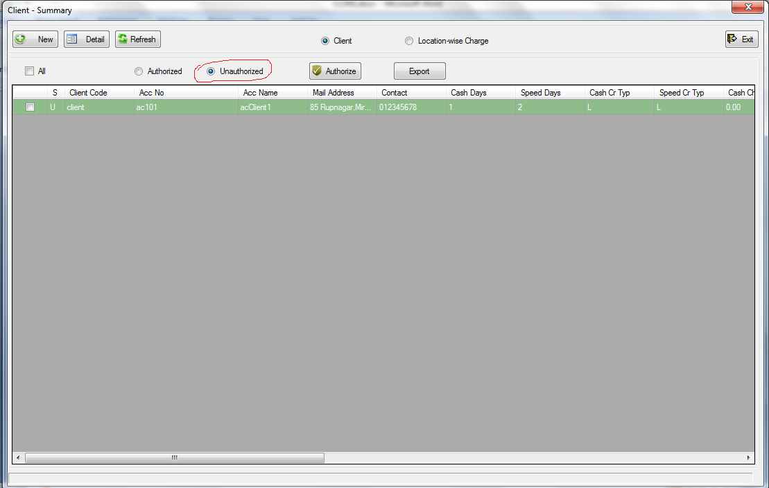

To edit or delete this client, double click on the client row. The details of the client will come in a “Client – Detail” form.

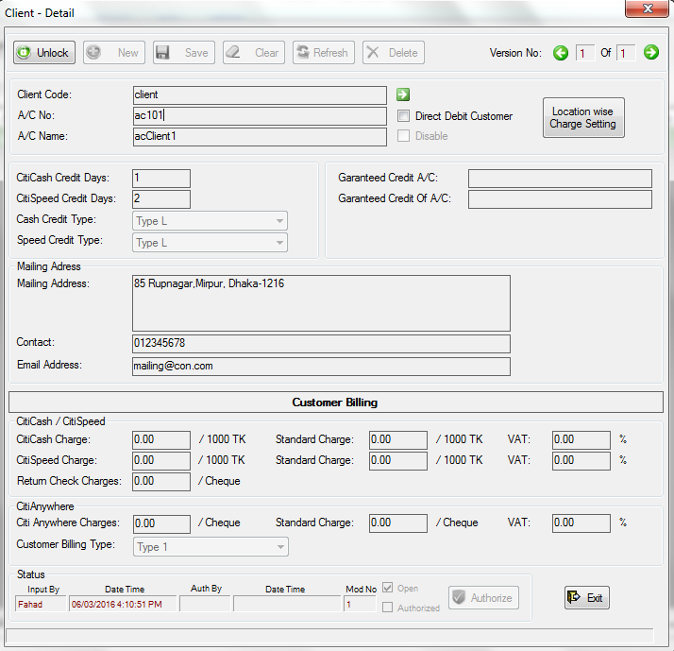

All the information is locked and in view-only mode. To make them editable, click on the “Unlock” button. They will be editable if you have enough permission to edit them. After editing them, just click the “Save” button to save the changes you made. You will be asked for confirmation. If you confirm by clicking “Yes”, the information will be updated.

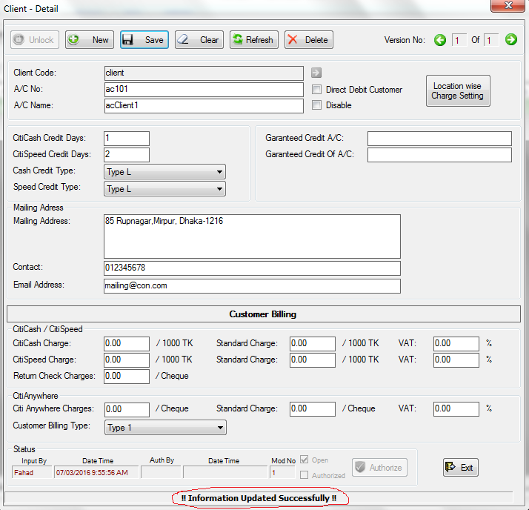

The post updating message will be shown at the bottom. If the update is successful, you will see “!! Information Updated Successfully!!”

To delete this client, click on the “Delete” button. You will be asked for confirmation. Confirm by clicking “Yes” if you are sure to delete.

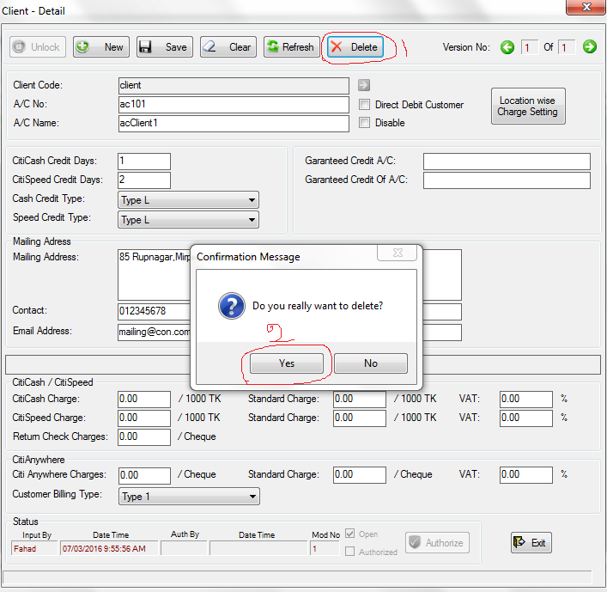

You will see post deleting message at the bottom. If the delete is successful, you will see “ !! Information Deleted Successfully !!”

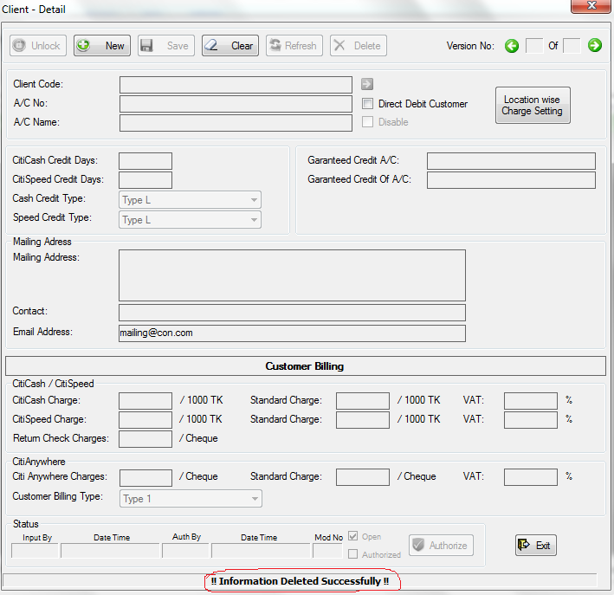

The process of insert, view, update, authorization, and delete of every item is same as the above insert, view, update, authorization, and delete process. So, the “Detail” and “Summary” sub-menu of every menu works in the same way.

As we have mentioned earlier, the “Branch” and “Clearing Branch” menu of “Maintenance” has an extra option named “Upload”.

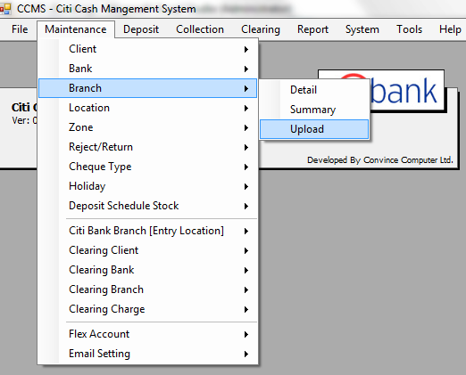

Using this menu, you can upload branch information with a fixed format MS Excel file. If you click the “Upload” menu, a form will come where you can locate your file. To select your Excel file, just double click the file or select the file and click the “Open” button.

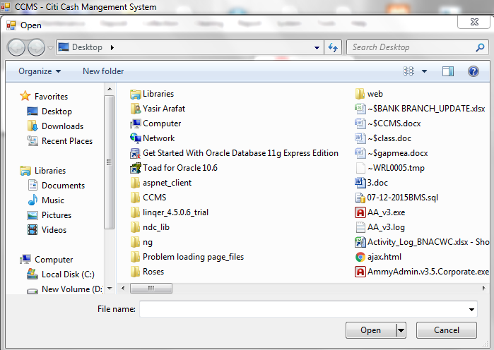

The format of the Excel file should be like:



You can use multiple sheets, but with same format. Once you select the file, the upload process starts uploading, and you will see the waiting message.

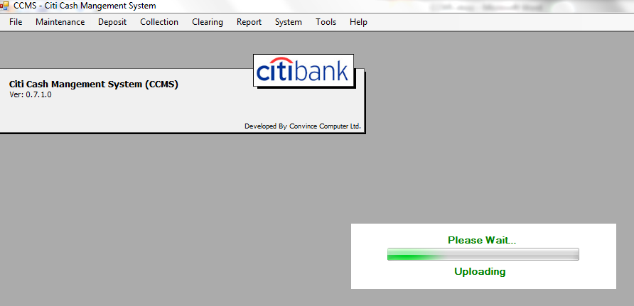

You will see post uploading message(s), when the upload finishes.

The “Upload” menu of “Clearing Branch” works like same as above.

Client: Detail: Purpose/Activity: Input a client, Table: Client

Summary: Purpose/Activity: To view, edit, authorize a Client, Table: Client

All other menus of Maintenance are similar to Client.

1. **Deposit:**

Deposit->Deposit Schedule:

To insert a new deposit schedule, go to Deposit->Deposit Schedule-> Detail. The “Deposit Schedule Information” form will appear. Click the ”Unlock” button to unlock the form.

The “New” button will be enabled if you have enough permission to unlock the form. Click the “New” button to insert a new deposit schedule. The form will be editable to you.

There may be one or multiple deposit(s) in a deposit schedule. The upper part of the form is to input deposit schedule information, and the lower part is for inputting individual deposit information.

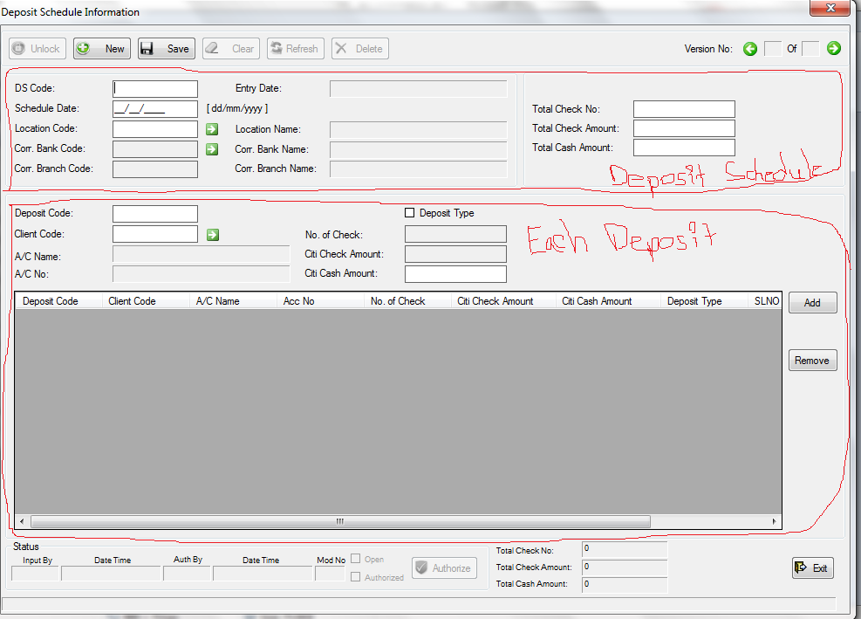

Suppose, we want to schedule a deposit with 2 checks, and some cash amount. Sum of the 2 check amount is 200, and cash amount is 100. We have to input this information at the upper right part. In the upper left part, we have to give a deposit schedule code (DS Code), Schedule Date. To enter Location Code, put the cursor in the Location Code input box and press “Enter”, or you can click the green right arrow button at beside the Location box input box.

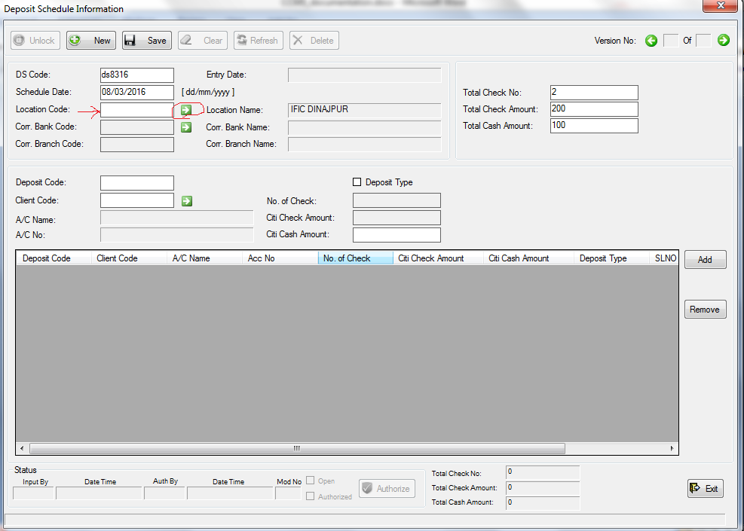

The “Location List” window will appear. To select a Location Code, just double click on that particular Location row.

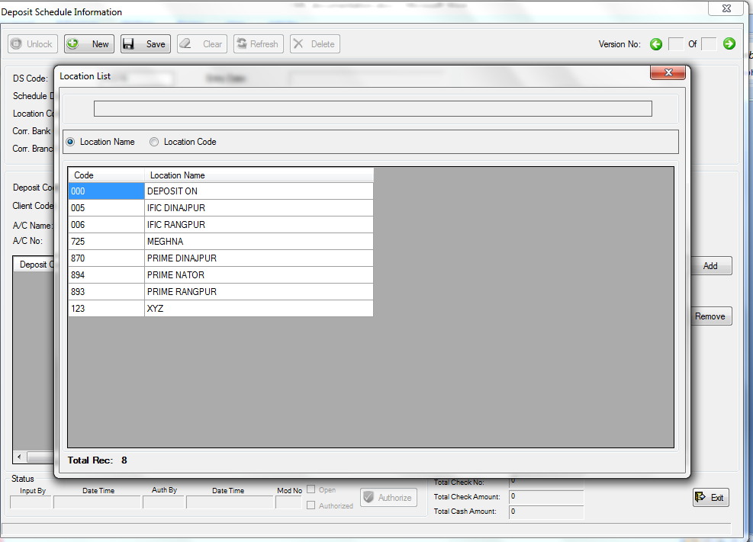

If the Location List is too large that you have to scroll down to find a location, don’t worry. You can search a location easily just typing the location name, or location code. You can see that there are 2 options at the above of the location list: Location Name, Location Code. By default, the Location name is selected. It means that if you type, the location list will be filtered by Location Name. 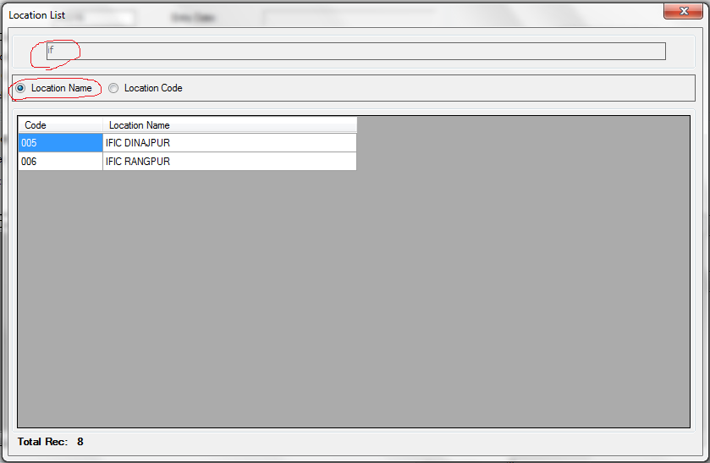

To search location by location code, just select the “Location Code” option and type location code.

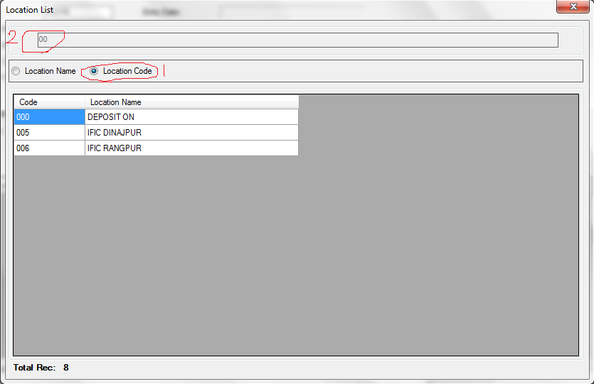

If you select a location by double clicking the location, you will see that the Location Code and the Location Name are placed to their corresponding input boxes.

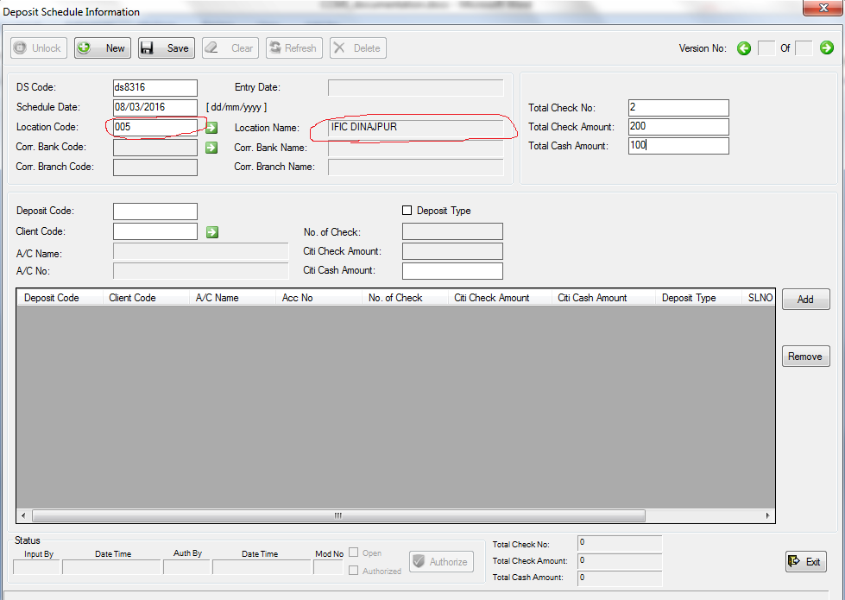

To select a corresponding bank code (Corr. Bank Code), and corresponding branch code (Corr. Branch Code), just click the green arrow beside the “Corr. Bank Code” input box (see the below screen shot).

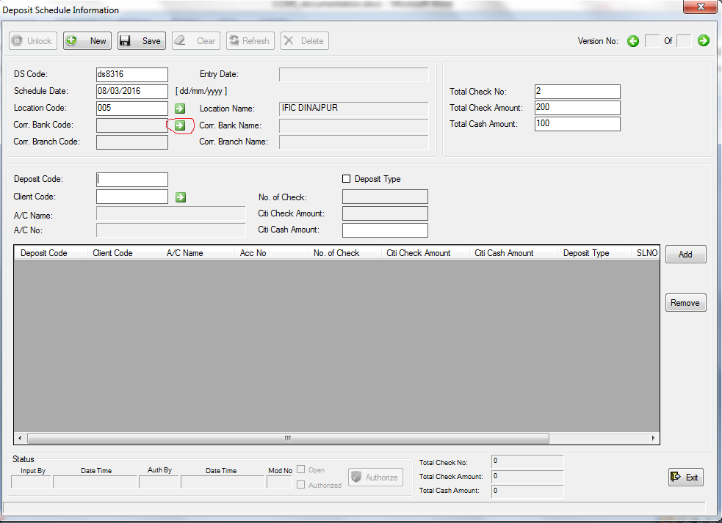

If you click that green arrow, the “Corr. Bank Branch List” will appear where you will see the corresponding bank branch(s) of the selected Location.

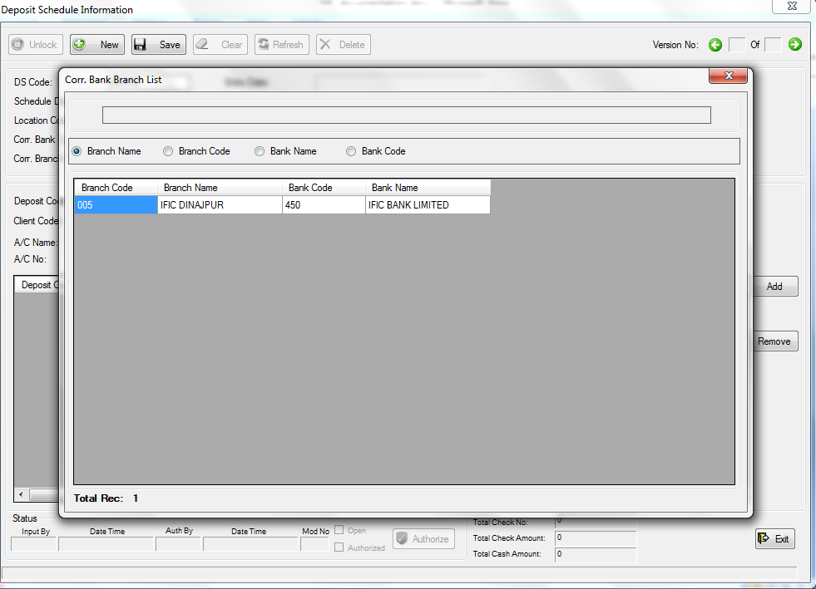

You can select a bank from here just like you selected Location earlier. As you can see, here are 4 different options at the above of the bank branch list, you can search bank branch with these 4 categories. Just select a category and type the value of that category to filter the list with that particular category.

If you select a bank branch from the bank branch list, you will see that the corresponding bank code, bank name, branch code and branch name is placed to their corresponding input box.

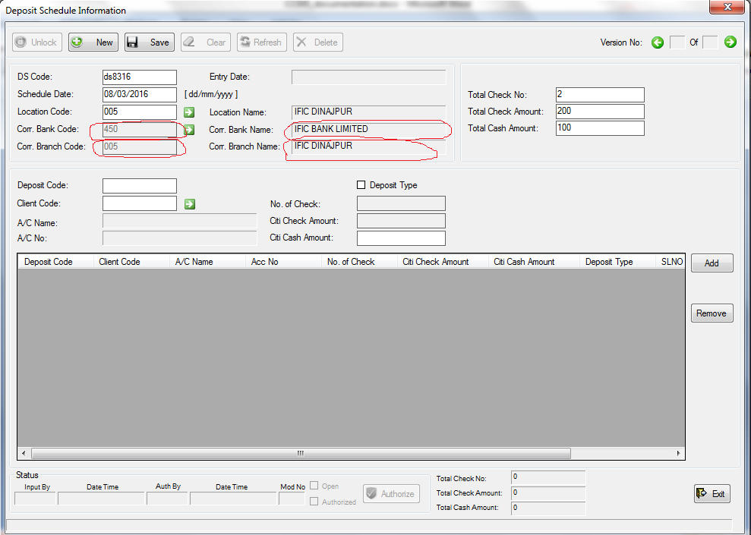

So, we are done for the upper part. Let’s go for the lower part.

In lower part, we can add the deposit(s) individually. There are two kinds of deposit: Cash and Check.

Cash and check(s) must be in different deposit. So, there is a checkbox for Deposit Type. By default, the checkbox is not selected, and that means the deposit type is Cash. So, the “No. of Check” and “Citi Check Amount” input boxes are disabled, and “Citi Cash Amount” input box is enabled.

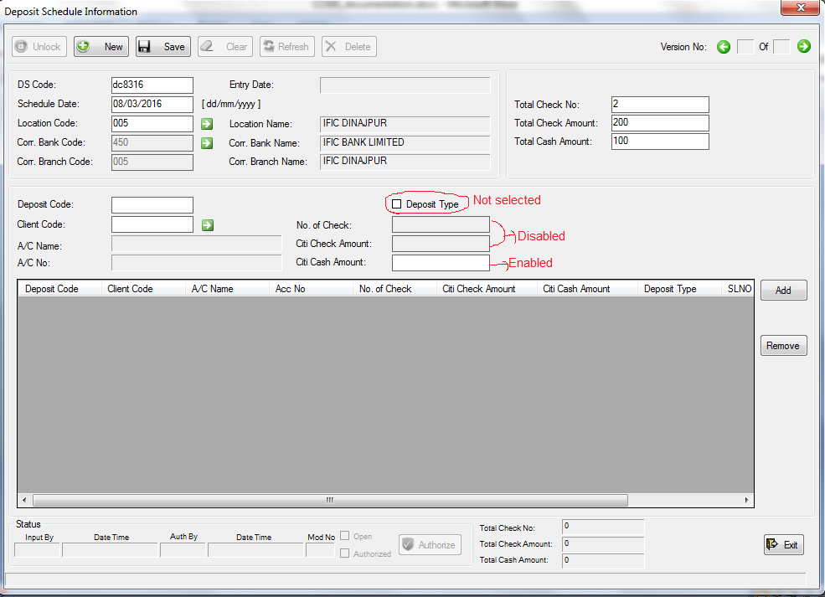

To enter a deposit, first we have to give a deposit code. Then we have to enter client code. To enter client code, put the cursor to the “Client Code” input box and press Enter. Or you can click the green arrow beside the “Client Code” input box. The “Client List” window will appear.

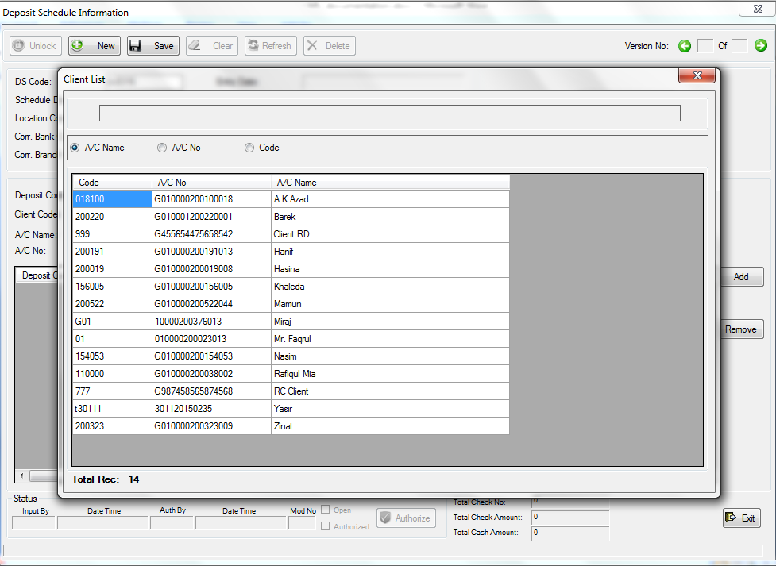

As you can see, there are three different options above the client list; you can search client(s) with these three categories: Account Name (AC Name), Account No (AC No), and Code (Client Code).

After selecting the client from the client list, you will see that the Client Code, A/C Name, and A/C No are placed to their corresponding input boxes.

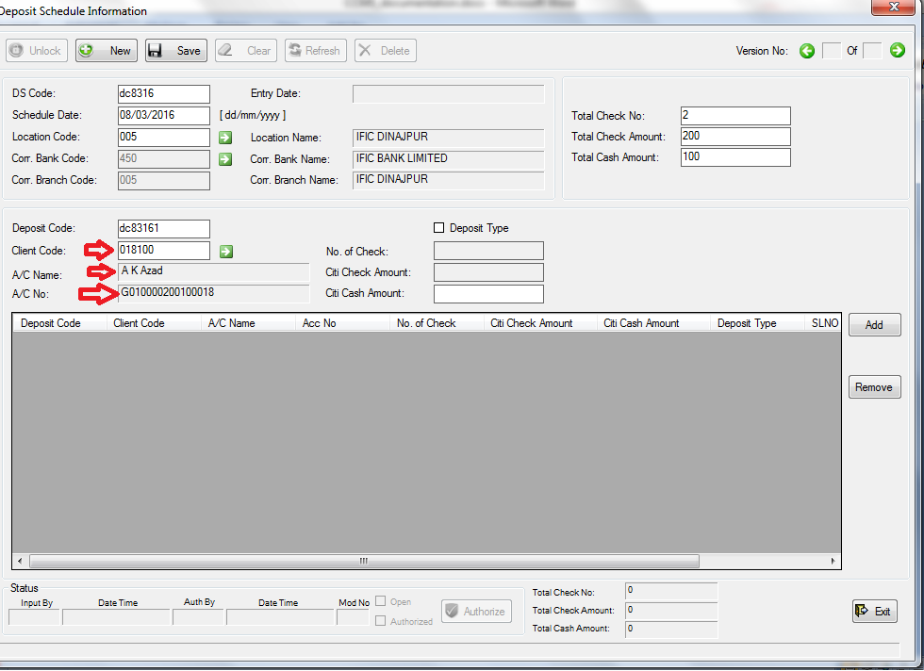

Now enter the cash amount to the “Citi Cash Amount” input box.

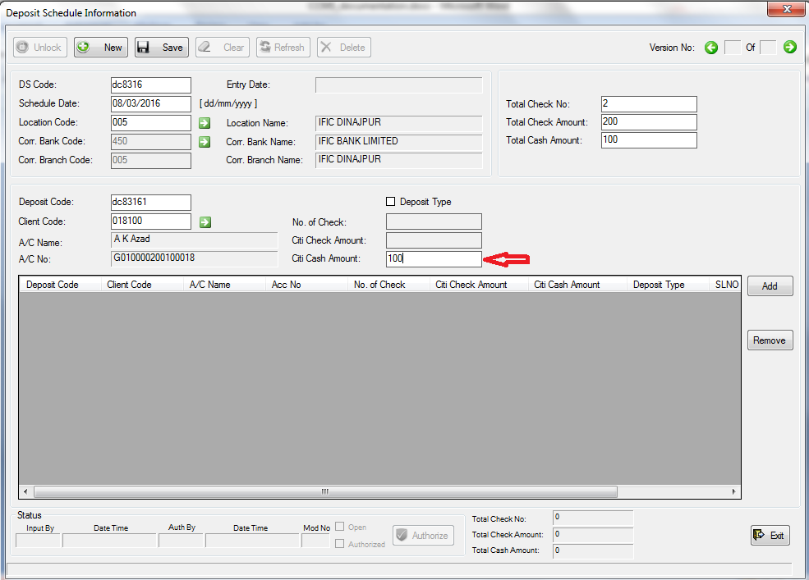

And then click “Add” to add this deposit.

If you click add, you will see that the information of this deposit will go to the list below, the “Deposit Code” and the “Citi Cash Amount” input boxes are cleared, and the “Total Cash Amount” at the bottom is updated.

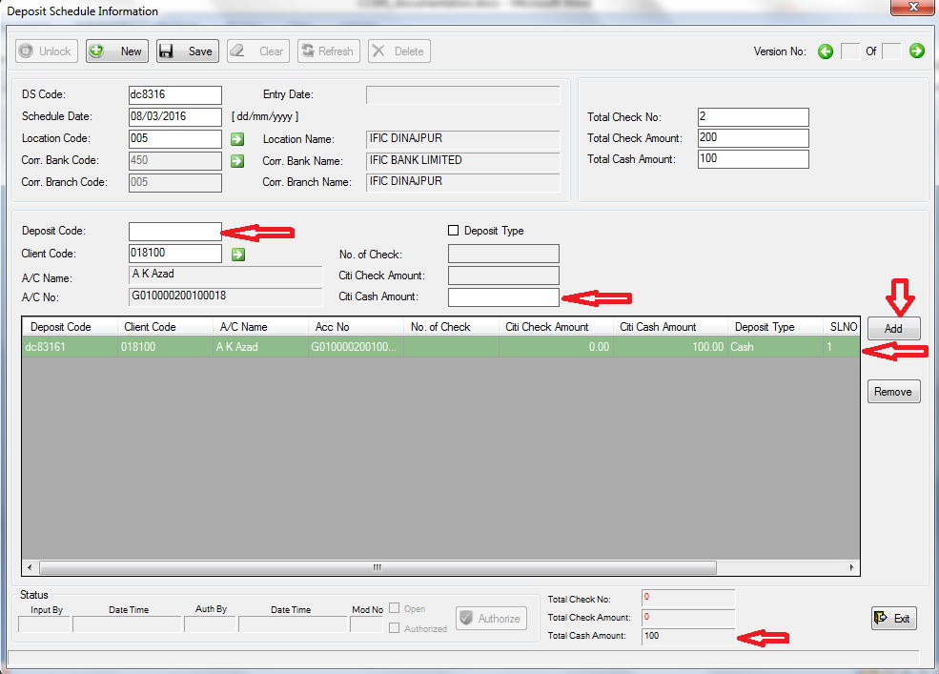

Now, let’s input the check deposit. At first we have to change the Deposit Type to Check. To do that, just click the “Deposit Type” checkbox. The “Citi Cash Amount” input box will be disabled, and the “No. of Check” and “Citi Check Amount” input box will be enabled.

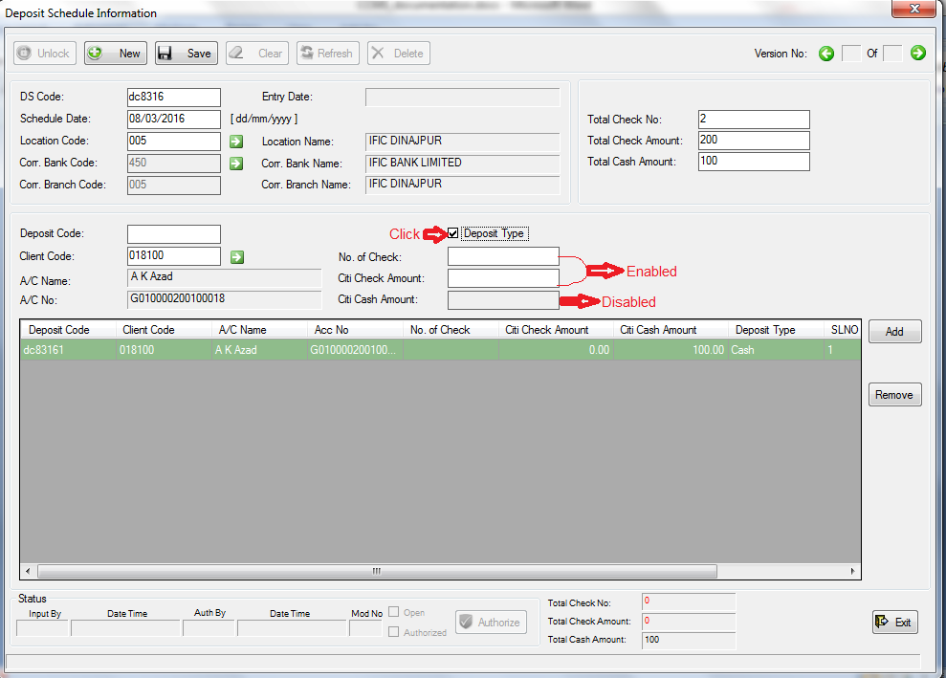

Give a deposit code, as every deposit should have a different code. We have 2 checks of amount 200. Suppose, we want to enter each check in different deposit (you can enter them in same deposit if you want to). So, we will input “1” to the “No. of Check” input box, and input the amount of this deposit to the “Citi Check Amount” input box. We will not change the client (you can change if you need to).

So, our second deposit will look like:

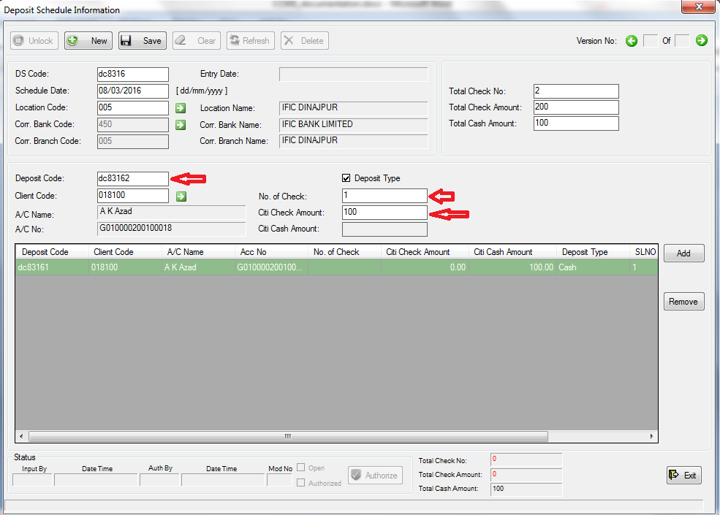

If we click “Add”, this deposit will be added to the list below. The “Total Check No.”, and “Total Check Amount” at the bottom of the list will be updated. And those three input field(shown with left arrow in the above screen shot) will be cleared.

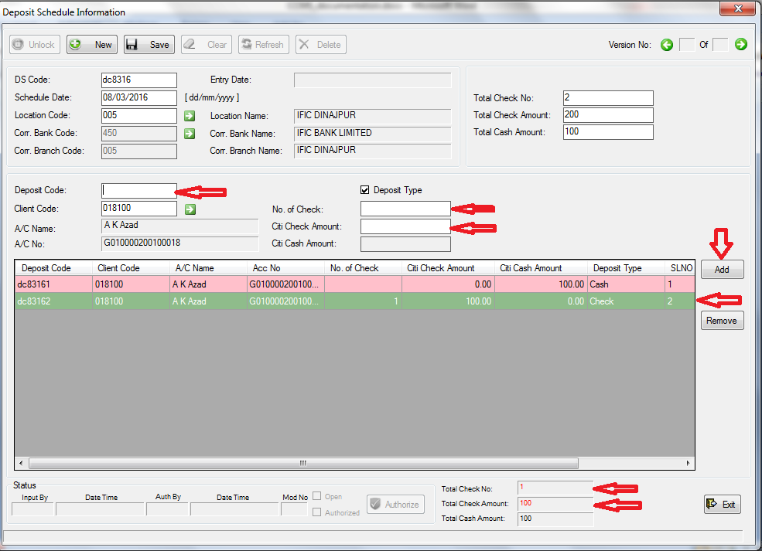

Have you noticed that the “Total Check No.” and “Total Check Amount” at the bottom of the added deposit list are in red color? It is because we have given 2 in the “Total Check No.” input box, and 200 in the “Total Check Amount” at upper part of the form. So, we need to deposit 2 checks with total amount of 200. Once we do that, these two field’s value’s color will be black. This scenario is called “Mismatch Total Value” in this software.

Let’s keep this as it is for this moment, and save to see what happens. If we click “Save”, we will be asked for confirmation. If we confirm that we really want to save, then we will be shown the mismatch information with warnings.

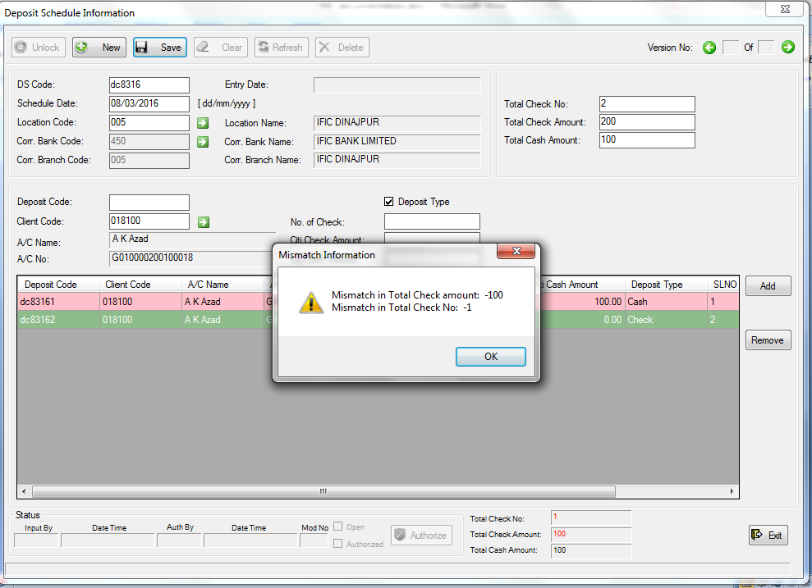

“Mismatch in Total Check amount: -100” means that we have given 100 less check amount in Deposit(lower part) than deposit schedule(upper part). It is true. Because we gave 200 to “Total Check Amount” at upper part, and we gave 100 to one check in lower part.

“Mismatch in Total Check No: -1” means that we have given 1 less check in Deposit(lower part) than deposit schedule(upper part). This is also true, because we gave 2 to :Total Check No.” at upper part, but inputted 1 check in lower part.

If we click OK, we will be shown “!! Information Added Successfully !!” at the bottom of the form. And the whole form gets cleared.

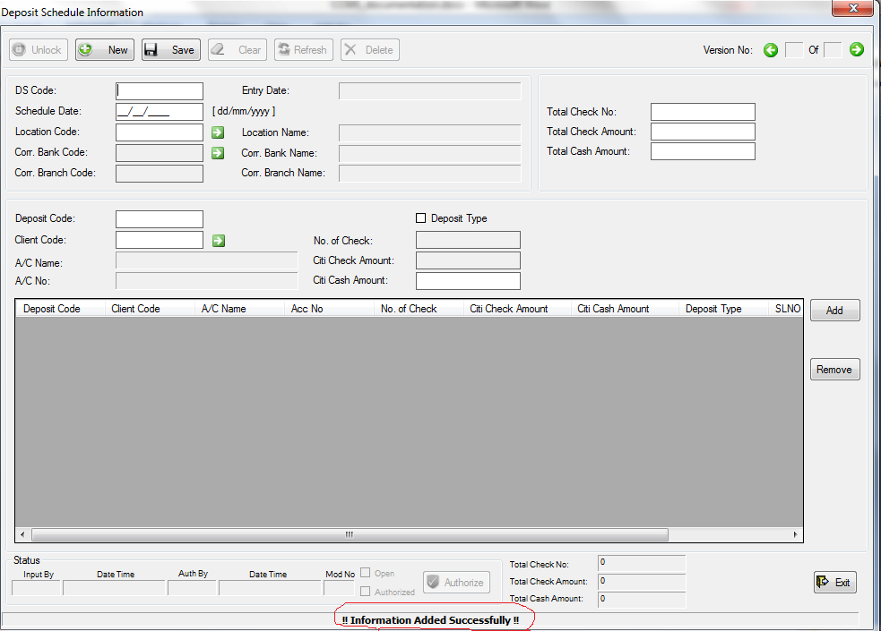

We have kept those mismatches intentionally to show you how to handle this situation.

Now, if you want to edit this deposit schedule to eliminate the mismatches, you can go to Deposit->Deposit Schedule-> Summary. You will find the deposit schedule in unauthorized list if the deposit schedule is not authorized yet.

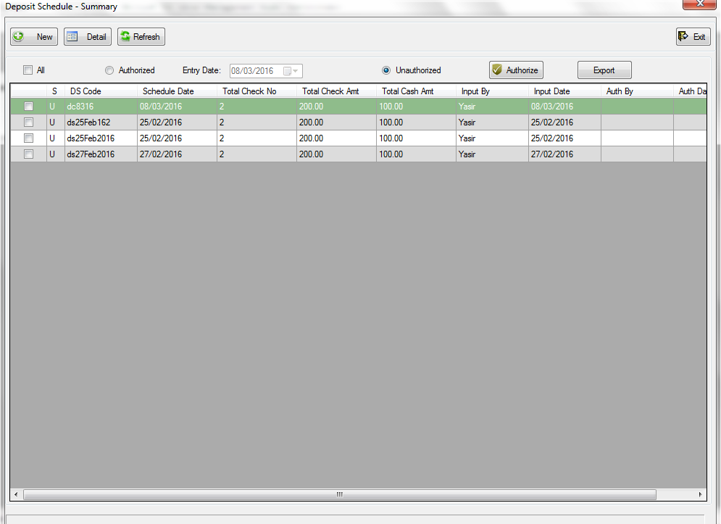

If you double click the row, click the “Detail” button after selecting the row, the deposit schedule information will be shown with a “Deposit Schedule Information” form.

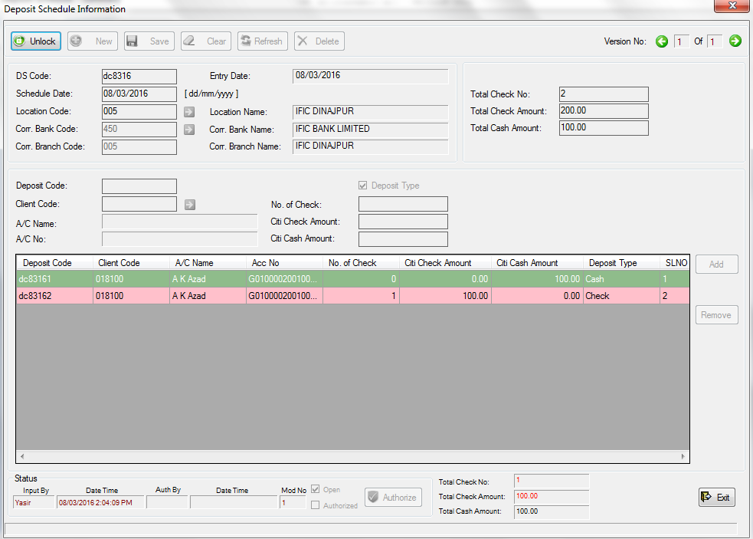

Click the unlock button to unlock the information to edit. The form will be editable if you have enough permission to edit this deposit schedule.

If the deposit schedule is authorized, you can find it in two ways. One is like finding the unauthorized: just go to Deposit-> Deposit Schedule -> Summary, and click on the “Authorized” option.

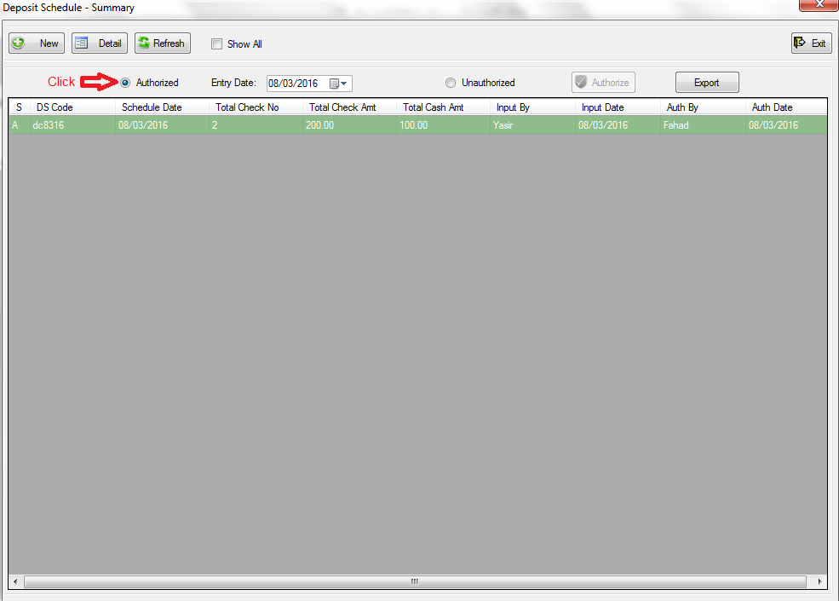

Alternately you can go to Deposit-> Deposit Schedule -> Mismatch Total Value. If the deposit schedule do not comes instantly, click the “Refresh” button. You will find the deposit schedule here, because it has mismatch values.

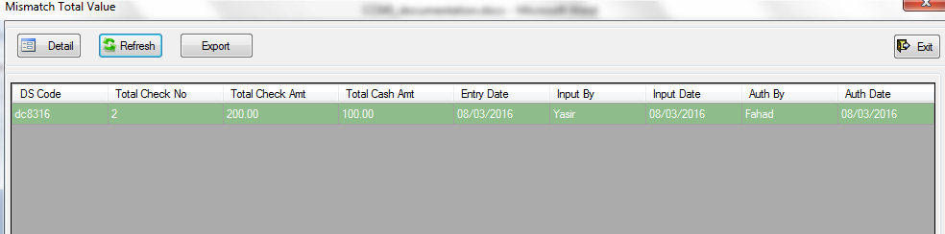

To edit it, double click the row, or select the row and click the “Detail” button to open it in a “Deposit Schedule Information” form.

Now we will enter the second check in a new deposit. Let’s do that as we did before.

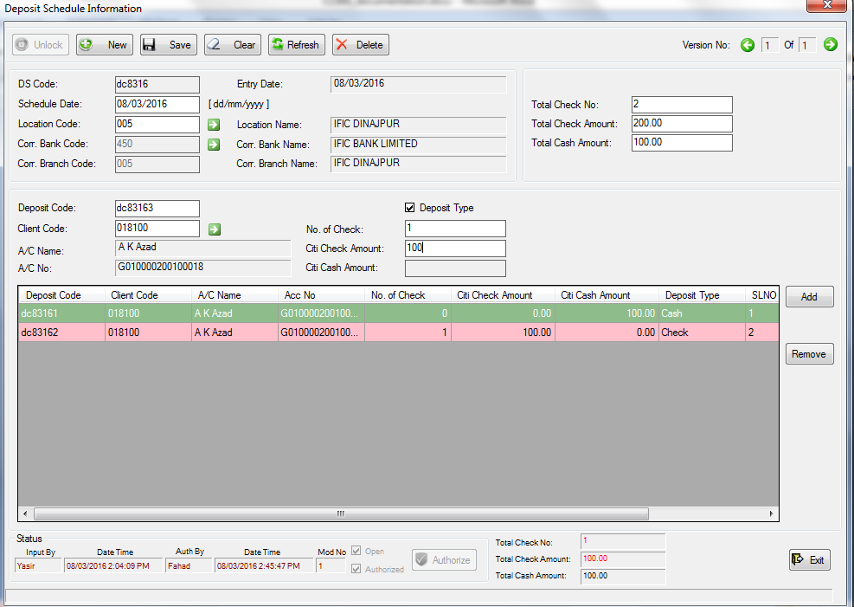

If we add this deposit by clicking the “Add” button, we will see that the “Total Check No.” and “Total Check Amount” values below the deposit list will be black as our total no. of check is 2, and total check amount is 200 (see upper right part).

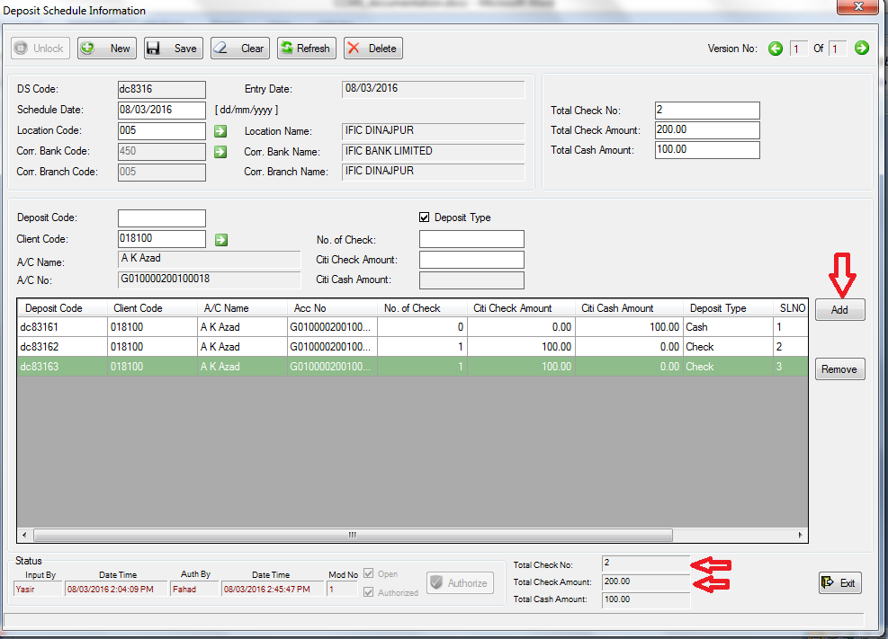

Now, if we save now, it will be saved without showing any warning, and we will be shown “!! Information Updated Successfully !!” at the bottom of the form as we have updated an existing schedule.

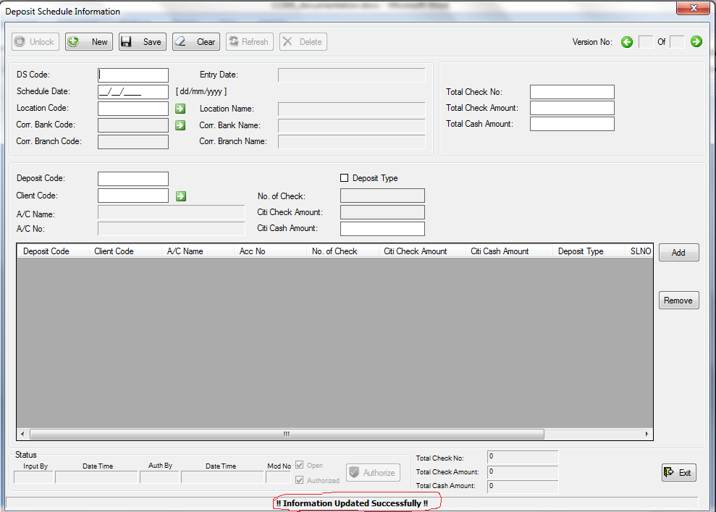

Now, we have completed inputting deposit schedule information, but didn’t input the cash and check detail yet. So, if we go to Deposit-> Deposit Schedule -> Missing CitiCash/CitiSpeed Detail, we will find those deposit records. (Click “Refresh” if the records do not come instantly).

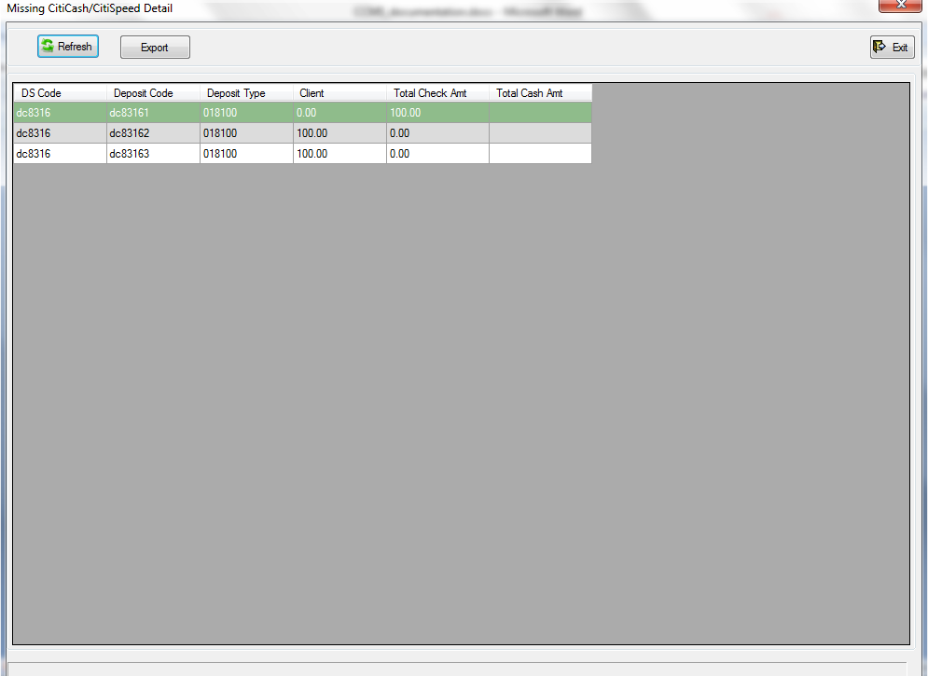

We have to input the cash and check detail of the deposits now.

To input cash detail, go to Deposit-> CitiCash Detail-> Detail. The “CitiCash Detail Information” will come.

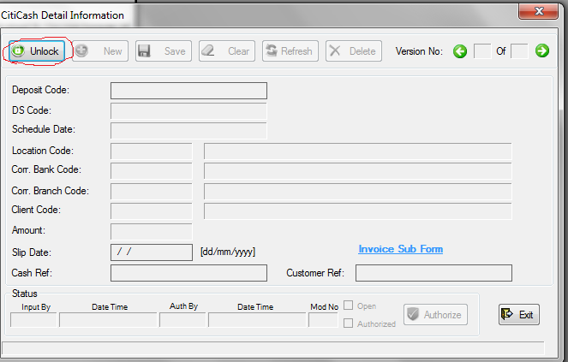

First, unlock the form by clicking the “Unlock” button. The form will be unlocked if you have enough permission to add a cash detail and the “New” button will be enabled. Click the “New” button to insert a new cash detail.

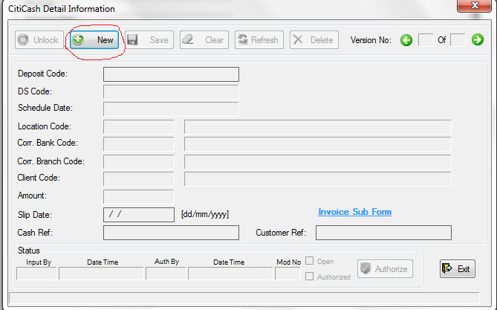

To insert a cash detail, first we have to enter the deposit code of the cash which we have given when inputting deposit schedule.

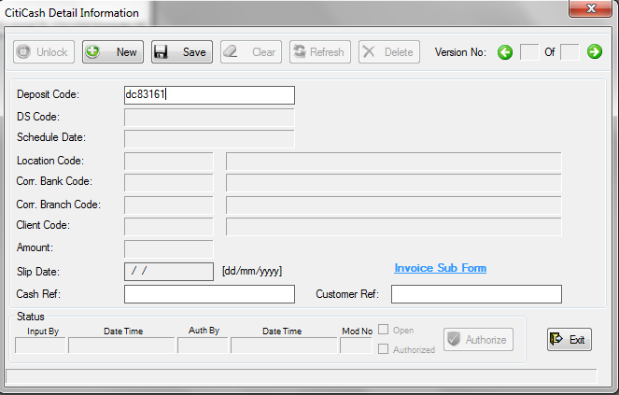

After entering the deposit code, press Enter or Tab to retrieve the deposit information of this cash deposit. (Or you can enter the cursor to Cash Ref or Customer Ref input box, or click any of the two green arrows).

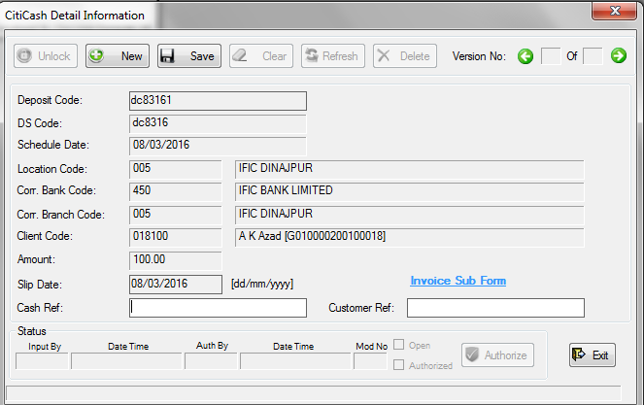

All the deposit information of the cash is retrieved. You can give a cash reference (Cash Ref.) and Customer Reference (Customer Ref.) if you need to. To enter invoice data, click on the “Invoice Sub Form”. The “Invoice” form will appear.

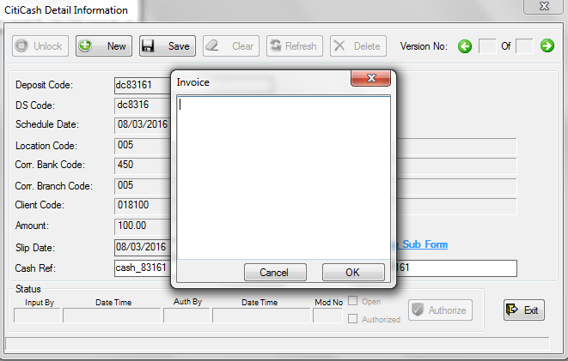

Enter your invoice data one in every line (press Enter for new line), and click OK.

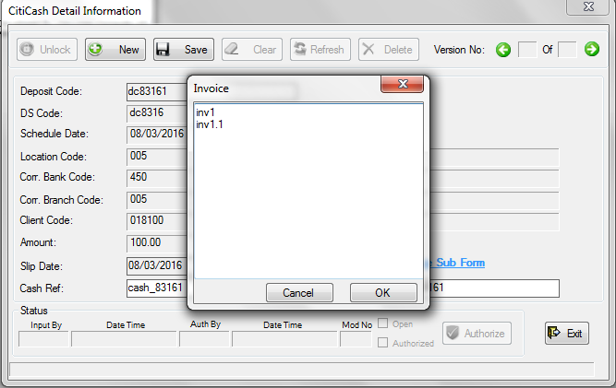

Now, save the cash detail by clicking “Save”, and confirming by clicking “Yes”.

If the cash detail is authorized, and we go to Deposit-> Deposit Schedule-> Missing CitiCash/CitiSpeed Detail, we will see that there are one less “Missing CitiCash/CitiSpeed Detail” in the list.

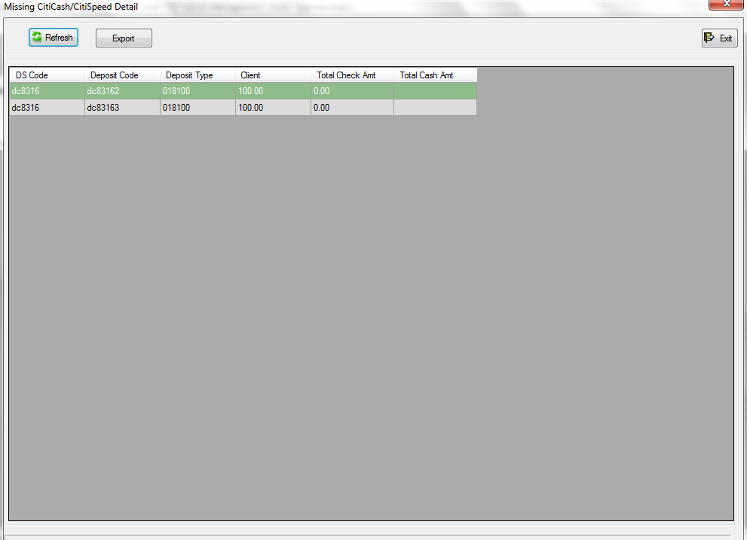

The cash detail is not here anymore, as we have inserted it, and it is authorized by someone.

We have now two missing check detail. Let’s insert them. To do that, we have to go to Deposit->CitiSpeed Detail-> Detail. The “CitiSpeed Detail Information” form will appear.

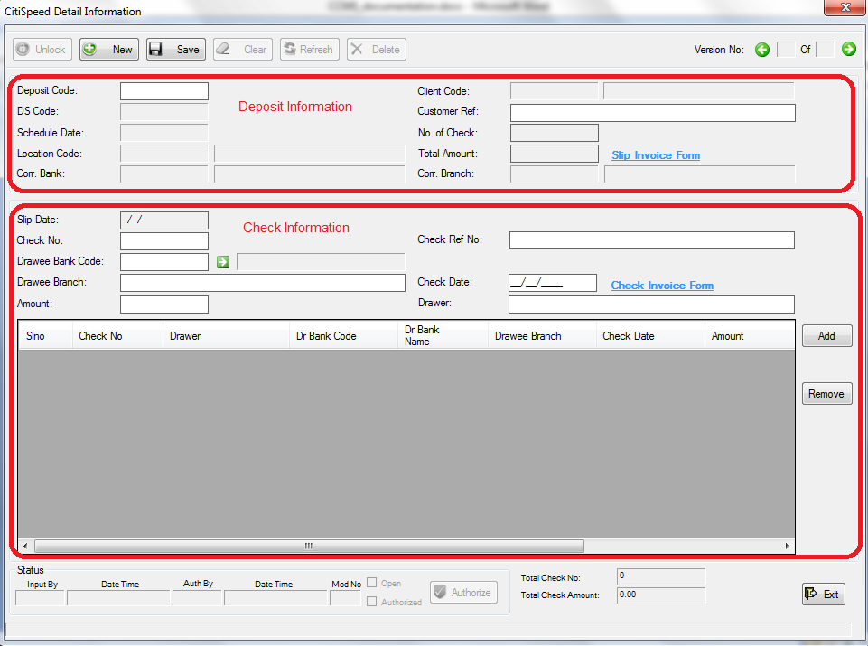

Unlock and click new to add check detail.

As we said earlier, a deposit may have one or more check(s). So, here are two parts in check detail. The upper part id for the deposit information, and the lower part is for check information. We can add one or multiple check(s) against a deposit.

At first, enter the deposit code to the “Deposit Code” input box and press Tab or Enter. The deposit information of the check will be retrieved.

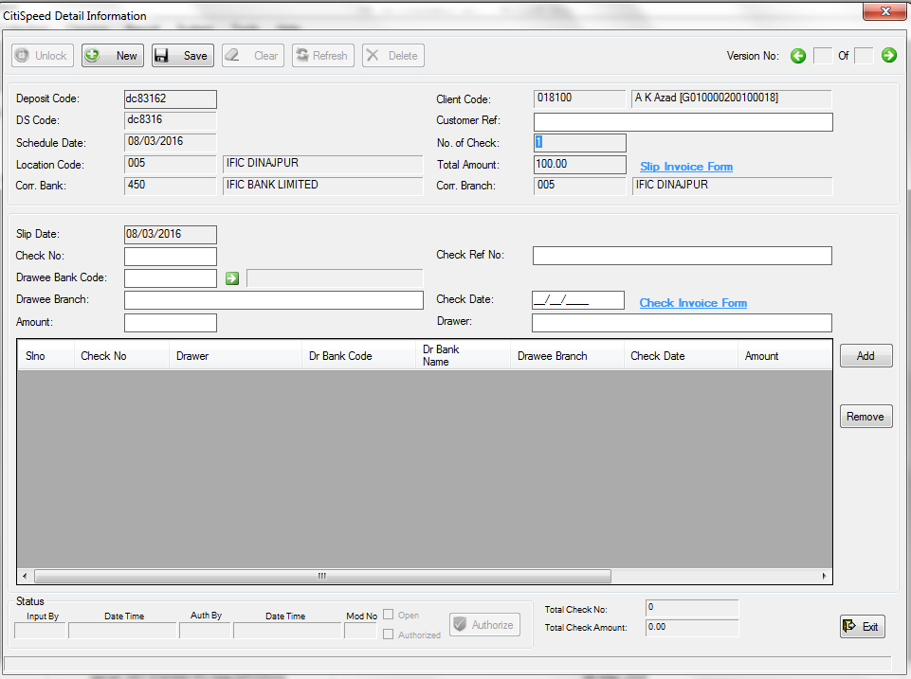

Enter a customer reference (Customer Ref.), and give slip Invoice (Slip Invoice Form) if you need to.

Now enter the check no. to the ”Check No.” input box.

T o select a Bank, click the green arrow beside the “Drawee Bank Code” input box (or you can press Enter keeping the cursor into the “Drawee Bank Code” input box). The “Bank List” window will appear. Select a bank by double clicking on the particular bank row (you can search if the list is too large to select .Searching process is described earlier). The bank code and bank name will be placed to their corresponding input boxes. Enter the amount of the check and give check date. Enter “Drawee Branch”, “Drawer”, and check invoice if you need to.

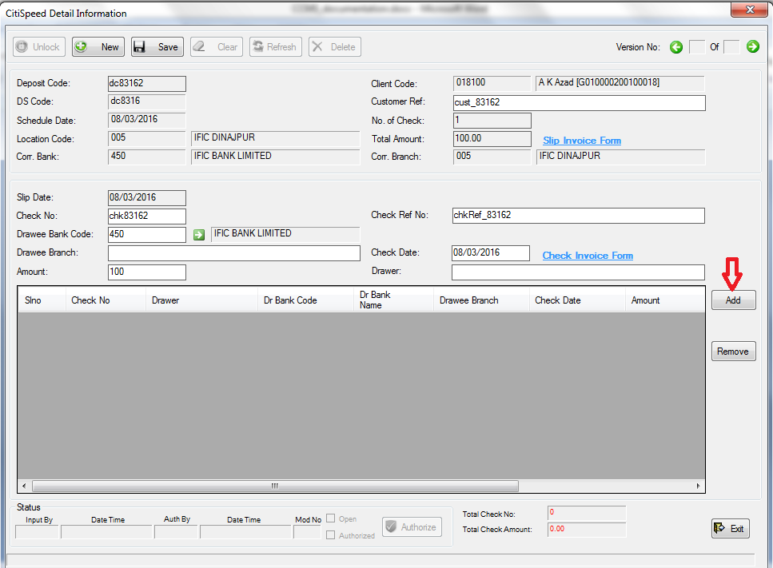

Click “Add” to add the check the list. The check will be added to the list and corresponding fields will be cleared to be ready for inputting another check.

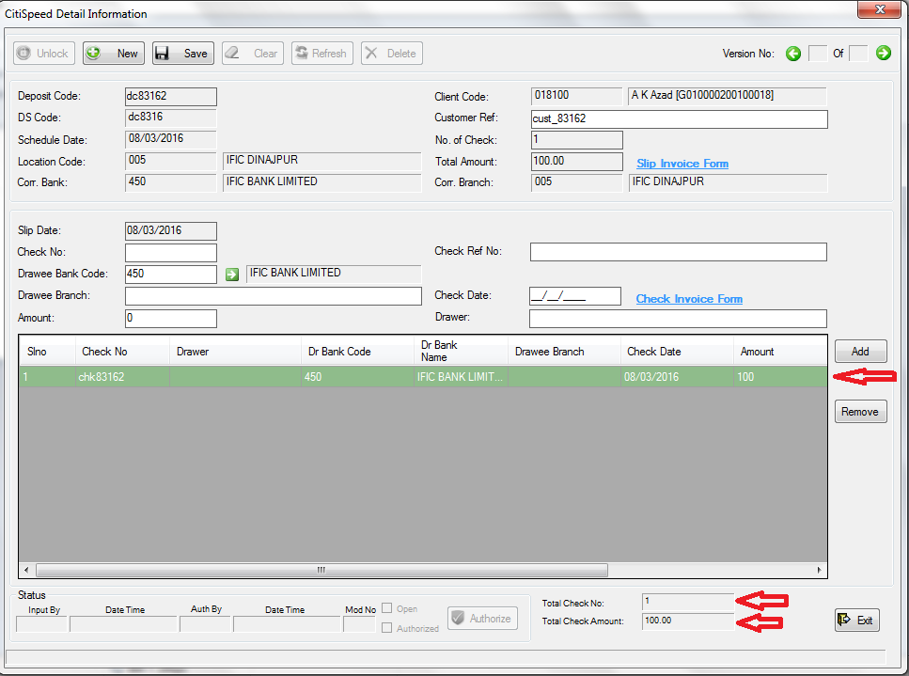

Now save the check clicking “Save” and confirming by clicking “Yes”.

If the check is authorized, and we go to Deposit->Deposit Schedule-> Missing CitiCash/CitiSpeed Detail, we will see that the number of “Missing CitiCash/CitiSpeed Detail” is less than one before.

We have one more deposit with one check of amount 100 which need to be inserted following the same process.

We have inputted the deposit and added the check to the deposit with amount of 10 instead of 100.

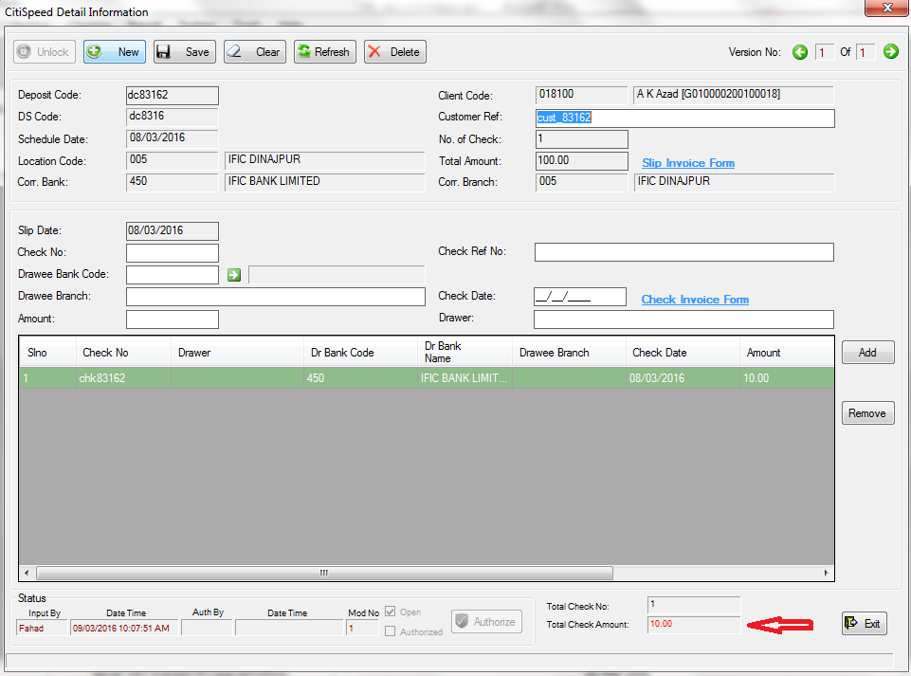

You can see that the “Total Check Amount” at the bottom is in red color; indicating mismatch of total check amount. If we save now, we will get warning, but it will be saved.

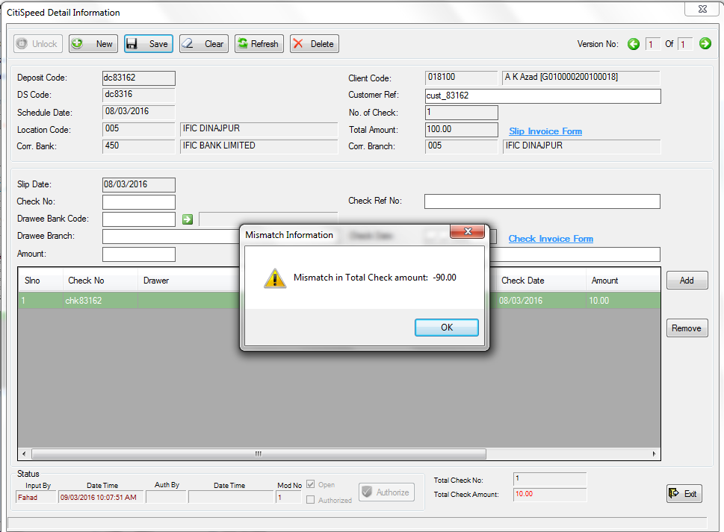

The warning “Mismatch in Total Check amount: -90.00” means that we have given 90 of amount less than the deposit total amount. If we click OK, we will see “Information Updated Successfully” message at the bottom.

What would be the warning if we give 120 instead of 100? Let’s try that.

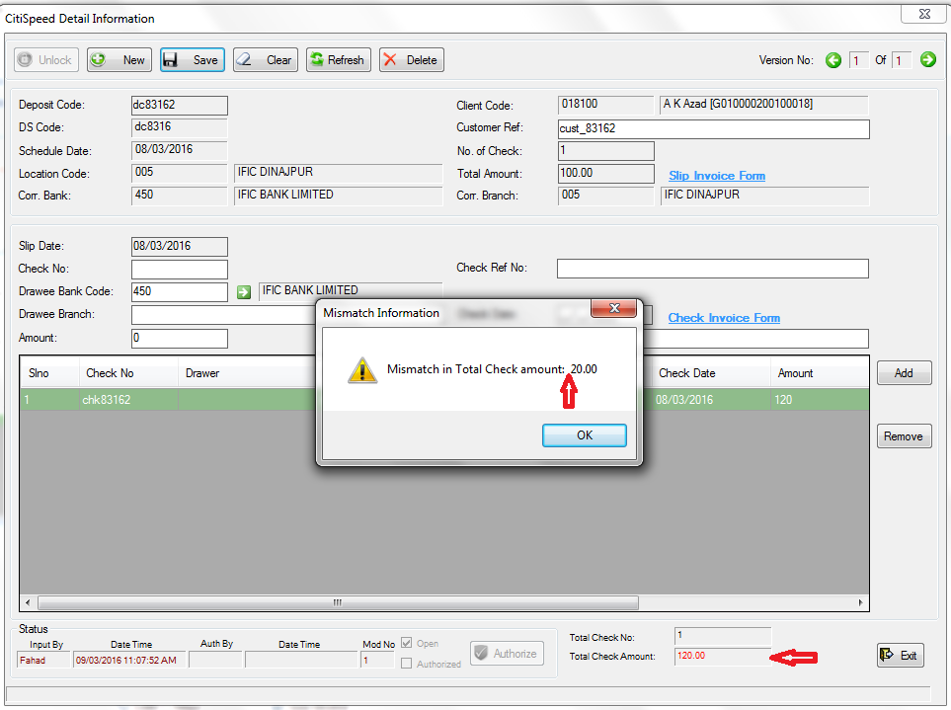

You see? The warning says: “Mismatch in Total Check amount: 20.00”. This time, no minus sign before 20, because we have given 20 of amount more than the total check amount.

If the deposit is authorized, we will find it in Deposit->CitiSpeed Detail-> Mismatch Total Value.

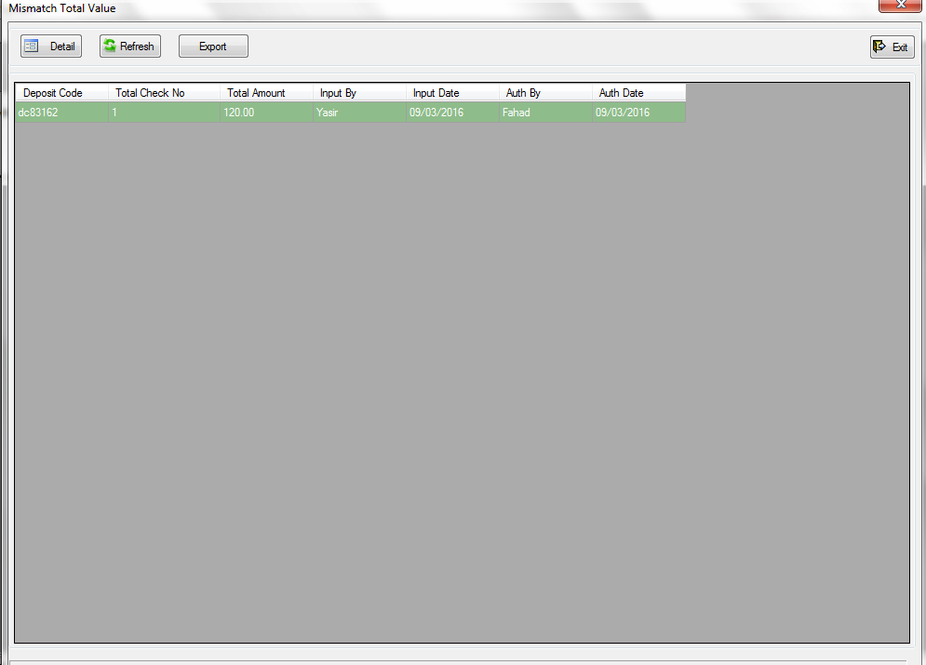

Double click on the row, or click “Detail” selecting the row to open it in a CitiSpeed Detail Information form from where you can edit, delete, or authorize it.

After opening it, double click on the check row to edit the check.

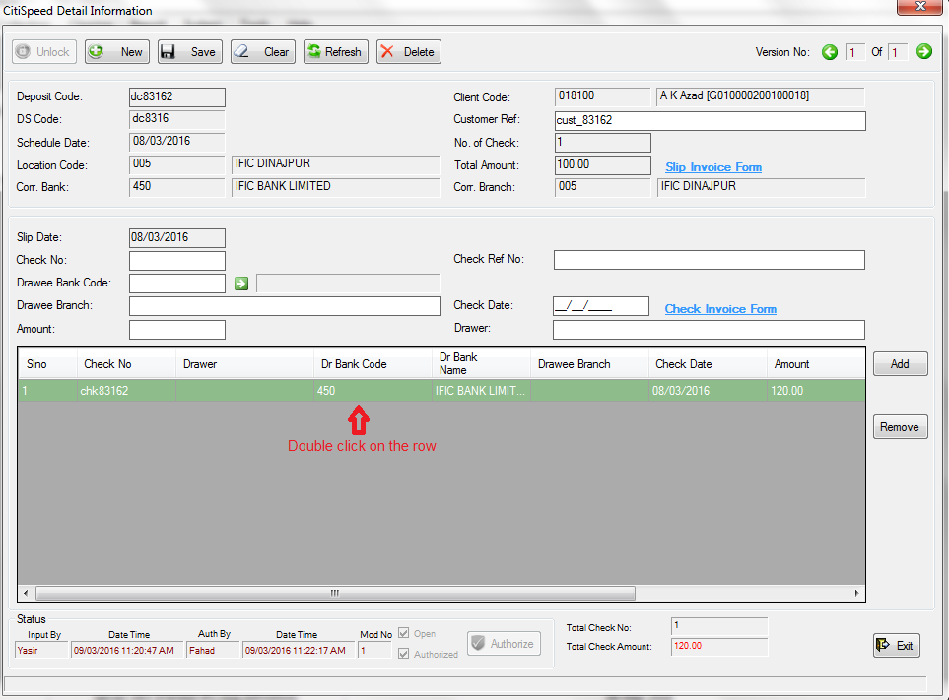

After double clicking the row, we will see that the check information goes up to the corresponding input fields, The “Remove” button gets disabled, “Update” button comes in the place of “Add” button, and another button named “Cancel” comes in the middle of “Add” and “Remove” button.

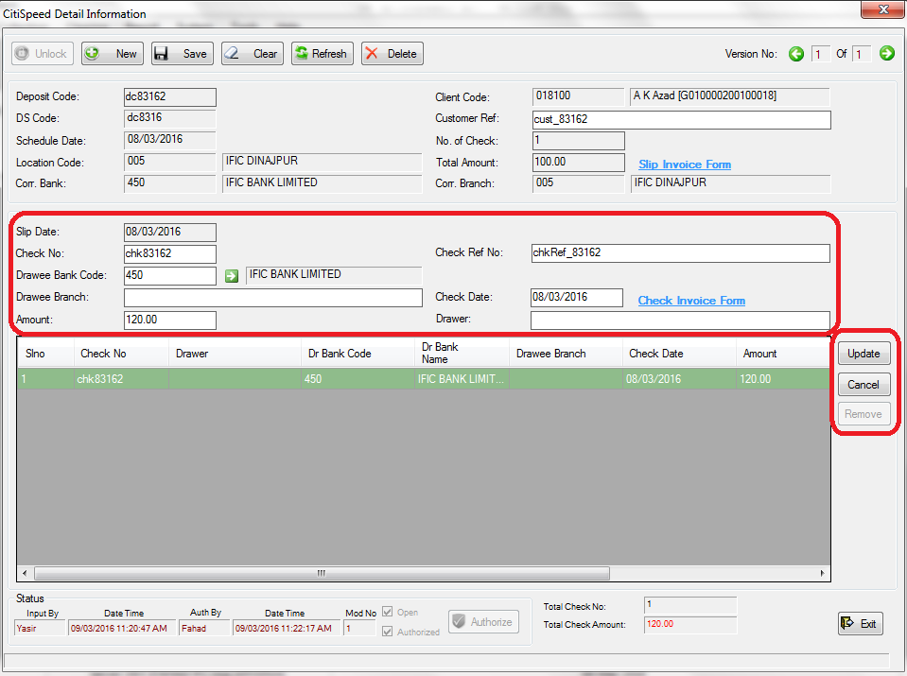

Now, we can change the check information. Let’s make the amount 100 and click on “Update” to update the information.

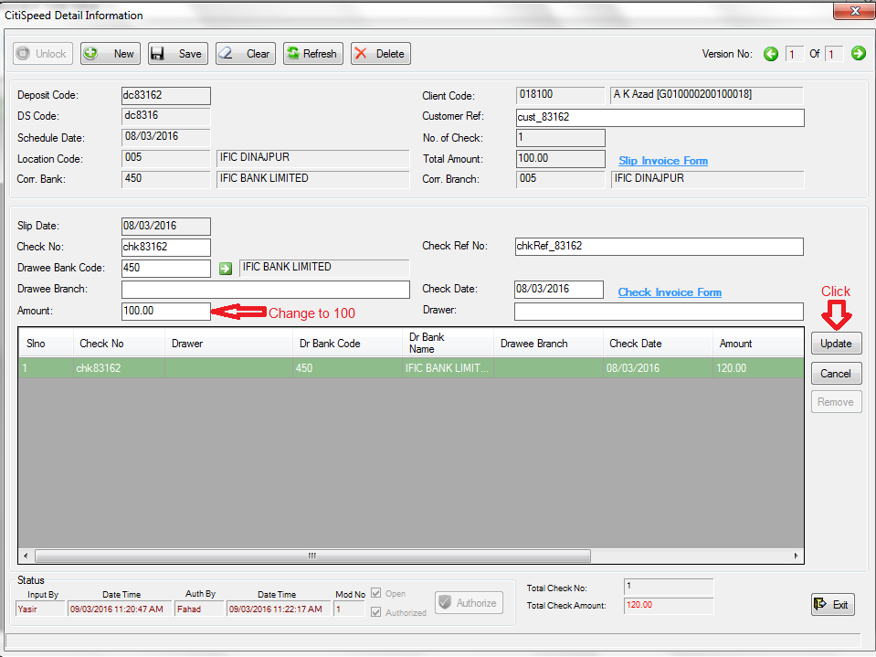

If we click update, we will see that the check row, and the “Total Check Amount” at the bottom is updated with the new amount 100. And the color of the “Total Check Amount” will be black as we have given same amount in check as we gave in deposit.

The “Update” button will be “Add”, the “Remove” button will be enabled, and cancel button disappears. We can remove a check row by selecting the row by clicking it, and then clicking the “Remove” button.

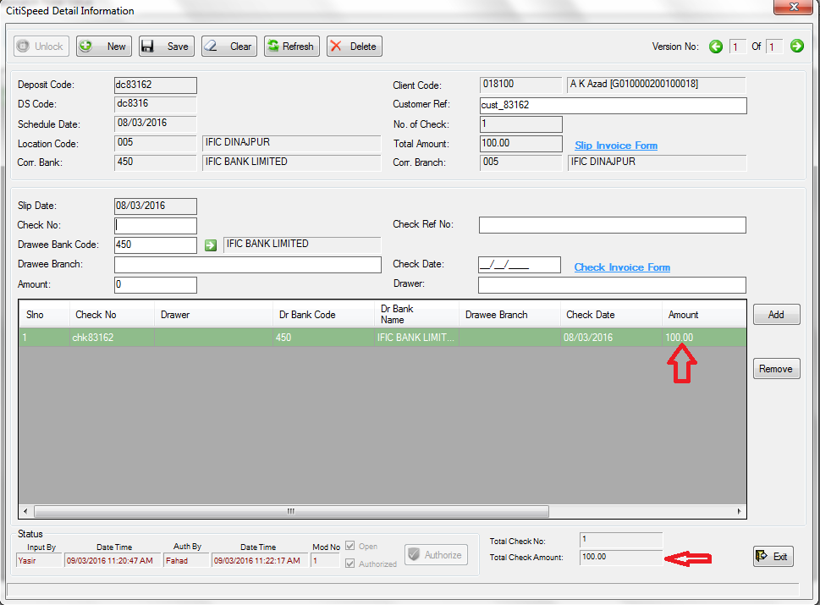

Now, if we save, it will be saved without any warning.

You may think that what if someone changes the information by mistake? Don’t worry. These changes will not effect until it is authorized by some author, and you can also get the previous information.

To get that, if it is not authorized yet, go to Deposit-> CitiSpeed Detail -> Summary. Click “Refresh” if the list do not populates instantly, and then double click the row, or click “Detail” selecting the row to open it with “CitiSpeed Detail Information” form.

If it is authorized, to get it, go to Deposit->CitiSpeed Detail-> Detail. Unlock and click “New”. Then enter the deposit code to the “Deposit Code” input box and press Enter or Tab.

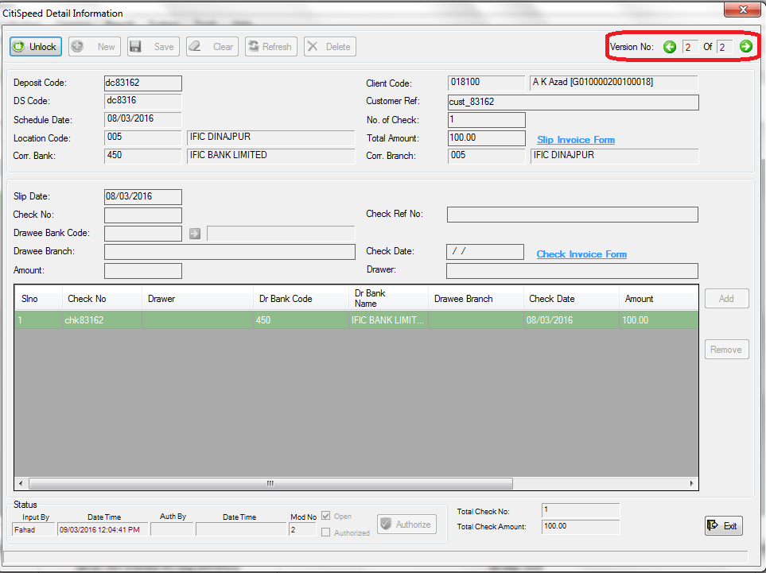

Look at the version of the information at the top right corner. It is version 2 of the same information. To get the previous version of this information, just click on the left green arrow. The version 1 of this information will come instantly.

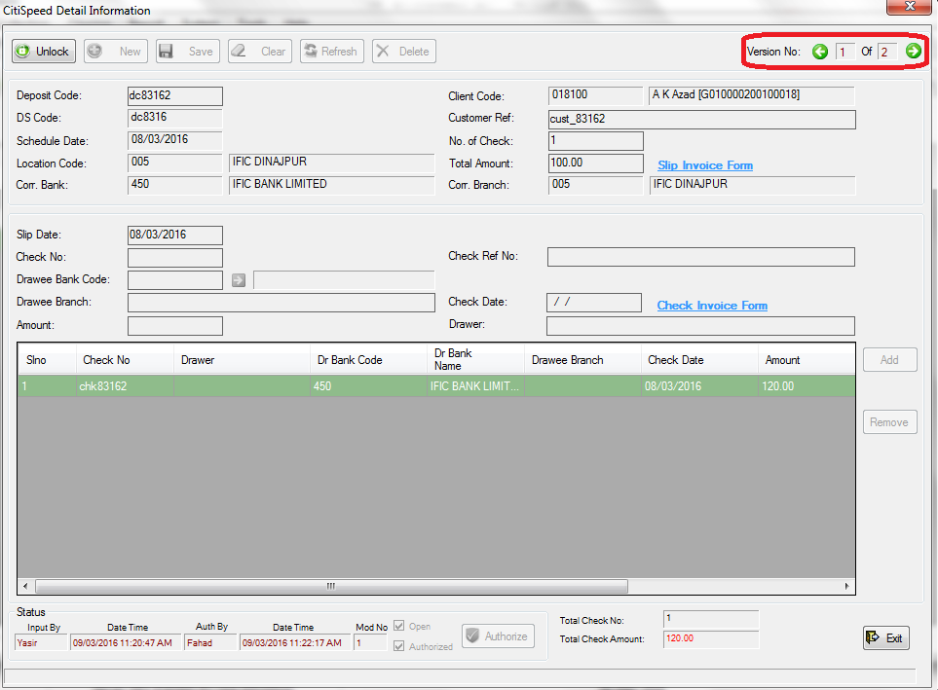

You can see the status of the information at the bottom left of the form. Status includes who inserted this version, when inserted, who authorized this version (if it is authorized), when authorized, and the version no. of this information (Mod No).

You can edit, or delete any of the versions you want to. The last version of the information will take effect in the system.

To search Deposit Schedule go to Deposit->Deposit Schedule->Search

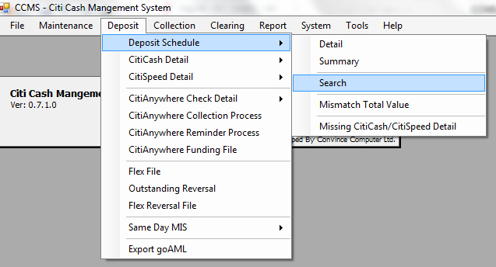

If you click on “Search”, a “Deposit Schedule Search” window will appear.

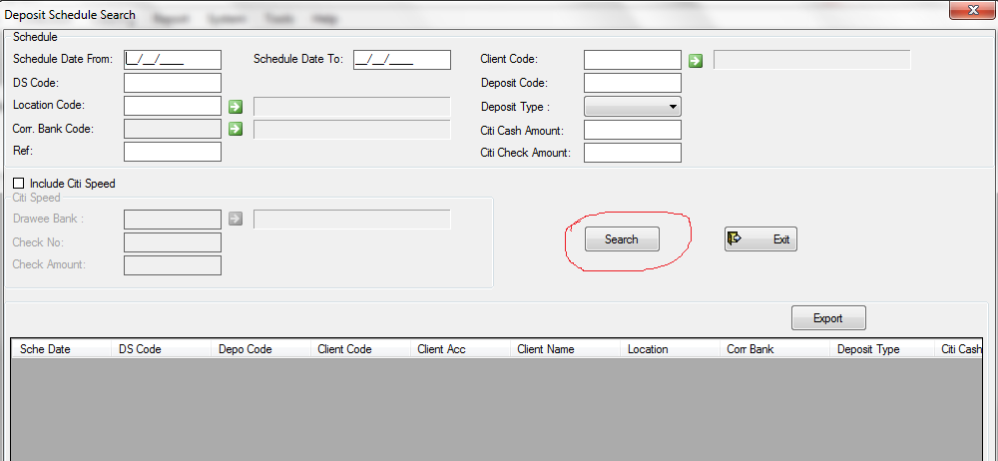

If you click on the “Search” button without giving any search keyword, the system will show all Deposit Schedule:

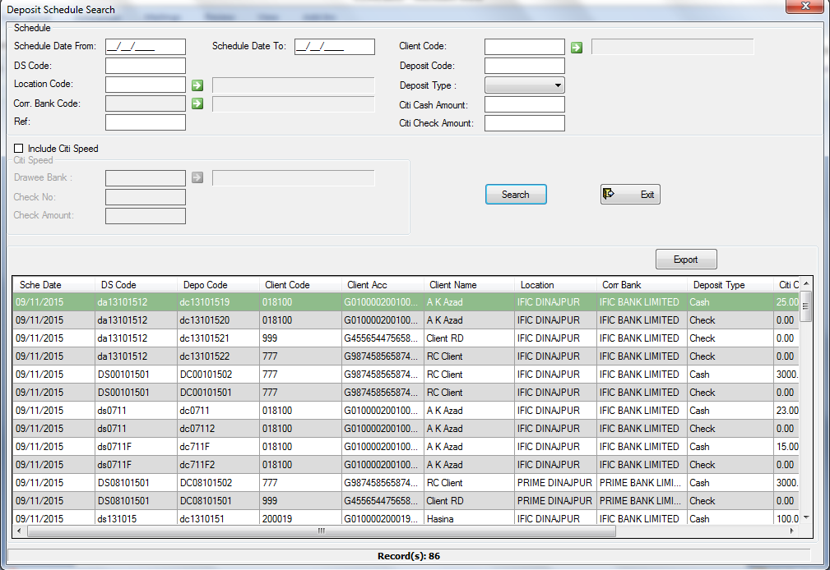

If you want to find the Deposit Schedule with a specific date range, then give the date range to “Schedule Date From” and “Schedule Date To”, and click Search.

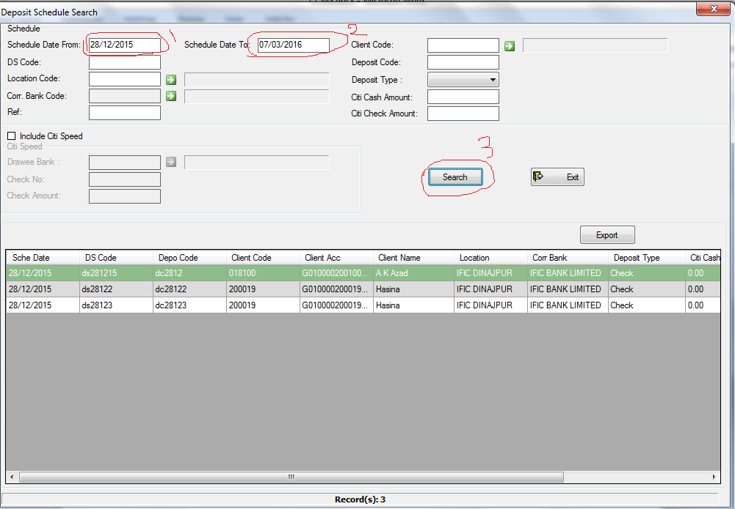

Similarly, if you want to search with different keyword, just enter that keyword, and click “Search”.

There is an “Export” button above the search result. If you want to export your search result to a MS Excel file, then click on it.

Deposit-> Deposit Schedule-> Mismatch Total Value:

When entering Deposit Schedule information from Deposit->Deposit Schedule->Detail, if there is mismatch between total check amount and sum of individual check amount, or total cash amount and sum of individual cash amount, then you can find those mismatches from here, and edit them to match with total value.

If the mismatch list do not comes after clicking “Mismatch Total Value”, then click “Refresh” button of Mismatch Total Value form. You can export the result to MS Excel file by clicking the “Export” button.

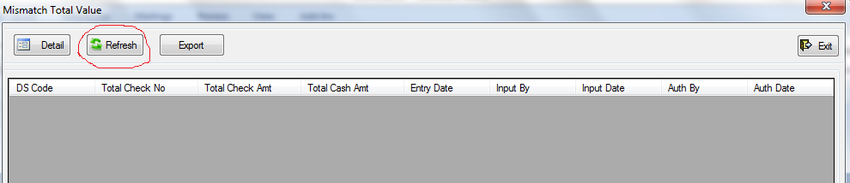

Deposit-> Deposit Schedule-> Missing CitiCash/CitiSpeed Detail:

If you enter some data in Deposit Schedule, but do not enter the cash detail from Deposit->CitiCash Detail->Detail or check detail from Deposit->CitiCheckDetail, then you can see the missing CitiCash/CitiSpeed list from here.

If the missing list do not comes after clicking the Missing CitiCash/CitiSpeed Detail, then click on the “Refresh” button of the “Missing CitiCash/CitiSpeed Detail” form.

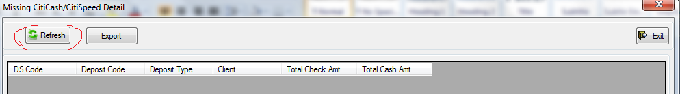

Deposit Schedule: Detail: Input a deposit schedule. Table: DSCHEDULE

Summary: To view, edit, authorize a deposit schedule. Table: DSCHEDULE

Search: To search a deposit schedule, export the search result

Mismatch Total Value: To see the mismatch of total values of deposit schedule

Missing CitiCash/CitiSpeed Detail: To see the missing record of deposit schedule, which are inputted in deposit schedule, but the detail are absent

CitiCash Detail: To input the cash detail of a deposit. Table: CCash

Summary: To view, edit, authorize cash

CitiSpeed Detail: To input check detail of a deposit. Table: CSD

Summary: To view, edit, authorize check

Deposit->CitiSpeed Detail->Mismatch Total Value:

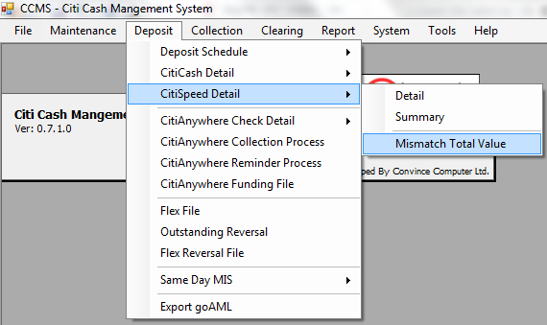

If you enter some checks in CitiSpeed Detail->Detail, the total amount should be equal to the sum of the amount of the checks you entered. If it is not, then you should edit them to match the total amount.

If there is such mismatches, you can find them easily find, edit, and export them from this menu(Deposit->CitiSpeed Detail->Mismatch Total Value).

CitiAnyWhere Check Detail: Detail: To input a check which can be deposited from anywhere. Table: CCheck

Summary: To view, edit, and authorized anywhere check

Search: To search and export CitiAnywhere check

Deposit->CityAnyWhere Check Detail->Search:

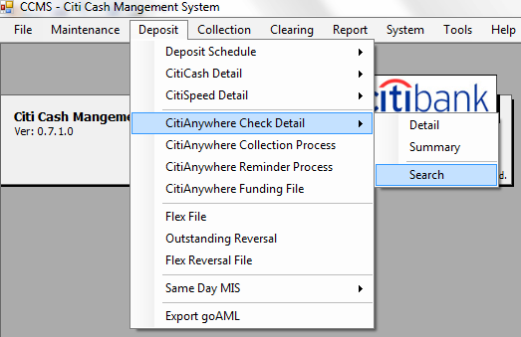

If you want to search CityAnyWhere check(s), which are inserted from Deposit->CityAnyWhere Check Detail-> Detail, then go to Deposit->CityAyWhere Check Detail->Search. The “CityAnyWhere Check Search” form will appear.

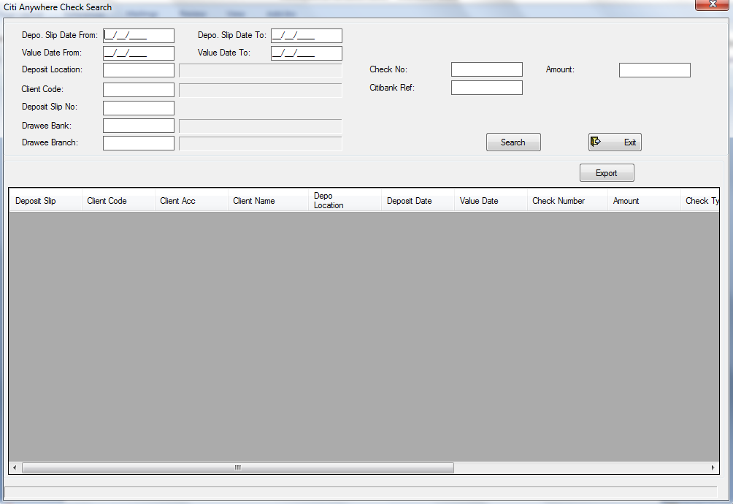

If you want to find all the CitAnyWhere checks, then click on the “Search” button without entering any search keywords. All the CityAnyWhere checks will be shown in the search result.

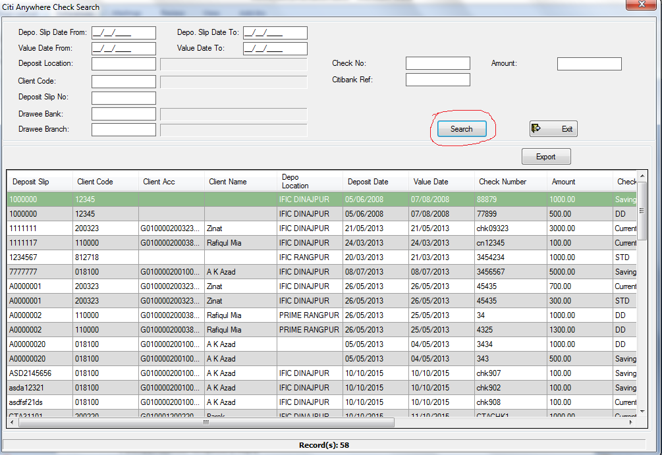

If you want to search by a specific keyword, enter that keyword in the specified input and then click the “Search” button. To export the search result to a MS excel file, click on the “Export” Button.

CitiAnyWhere Funding File: To generate the CitiAnyWhere Funding File. Table: CitiAny_Fund

Deposit->Flex File:

To generate Flex file, go to Deposit->Flex File

A “Booking File Generation” form will appear.

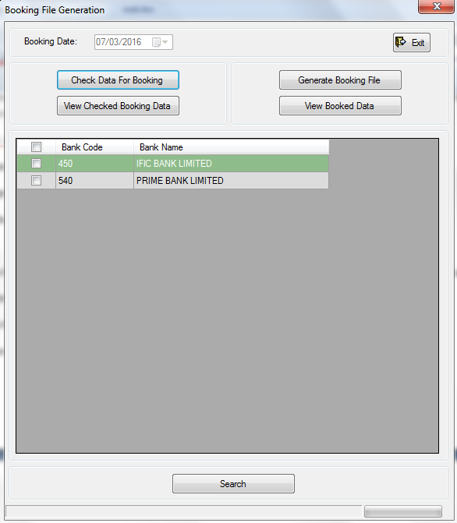

To generate a flex file you have to select bank(s), check the booking data, and then generate the file.

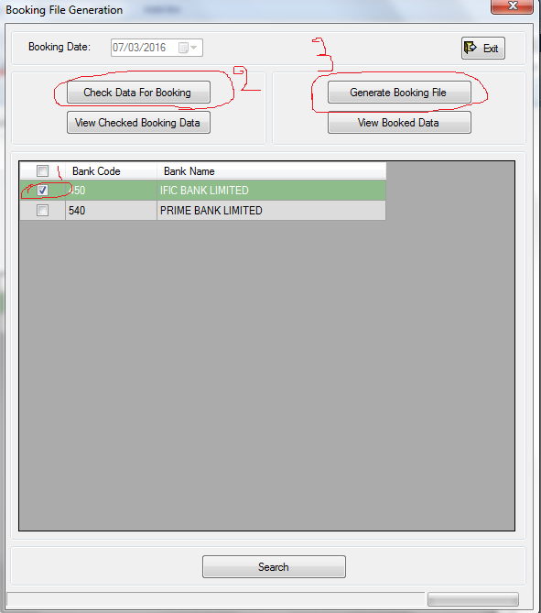

To select all the banks at a time, click the left tick box of the row header (beside “Bank Code”).

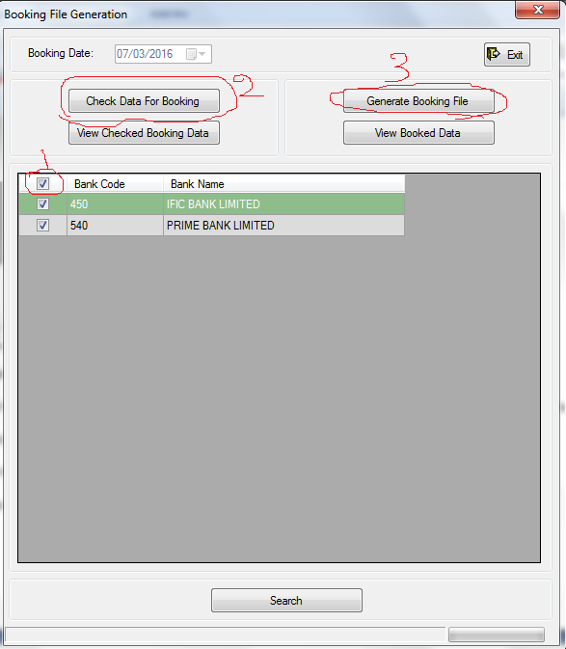

You can view the checked booking data by clicking the “View Checked Booking Data” button after checking data for booking.

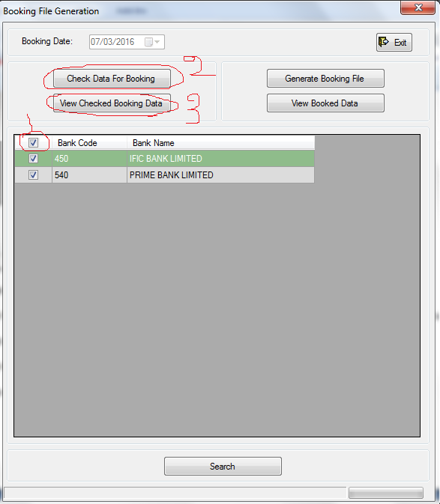

You can also view the booked data by clicking the “View Booked Data” after generating the Booking File.

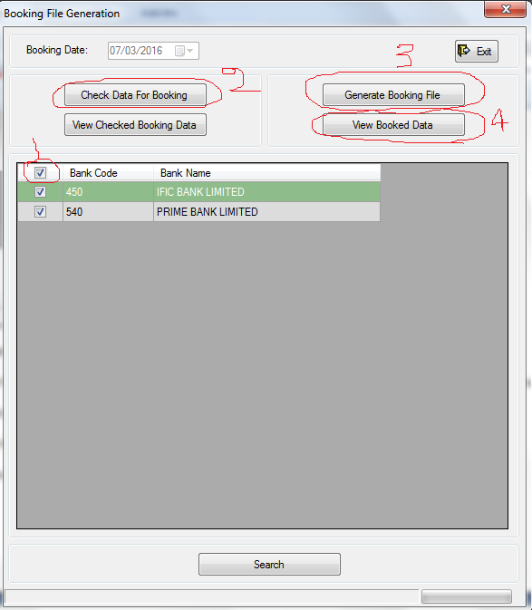

Or,

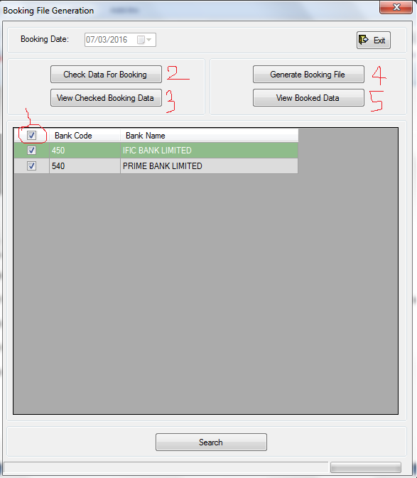

Flex File: To generate booking file, check data for booking, view checked booing data, and booked data

Deposit-> Outstanding Reversal:

If you want to search the outstanding reversal items, update their status then go to Deposit-> Outstanding Reversal. The “Outstanding Reversal Items” form will come.

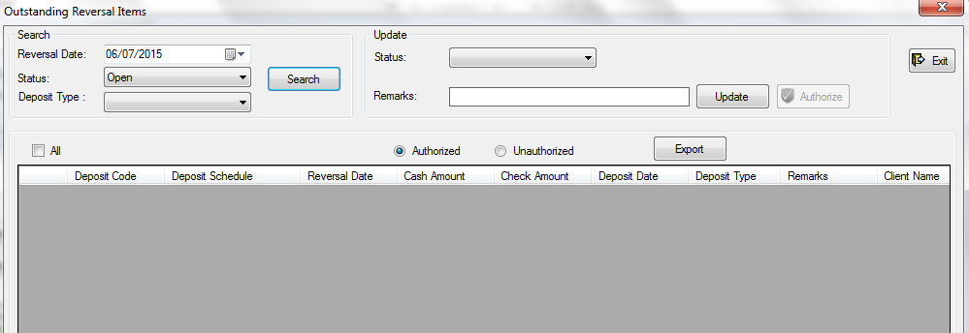

You can search outstanding reversal items with specific search keywords. Enter the keywords first, and then click the “Search” button.

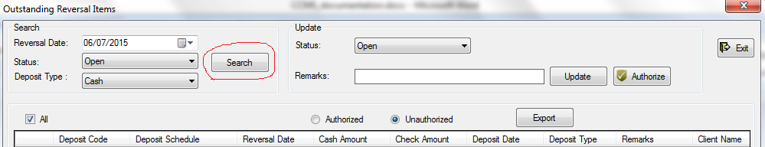

To update status of reversal item(s), select those item(s), then select a status, give some remarks if you want to and click the “Update” button.

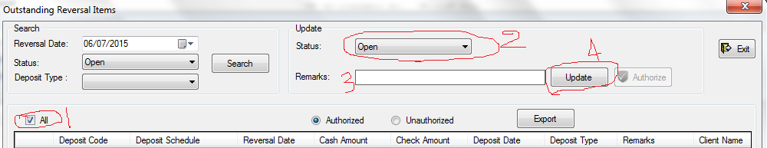

To authorize a reversal item, click on the “Unauthorized” option. The unauthorized items will be shown, and the authorize button will be enabled. Select the reversal item(s) to authorize, and then click “Authorize” button to authorize.

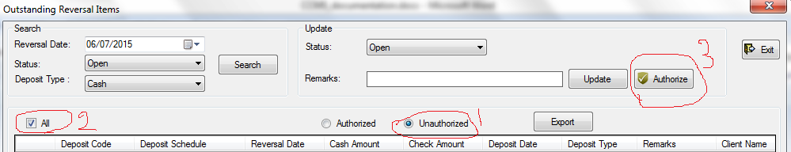

Outstanding Reversal: To view the outstanding items, change their status, and export.

Deposit-> Flex Reversal File:

To generate Flex Reversal File, go to Deposit-> Flex Reversal File. The “Reversal File Generation” form will come.

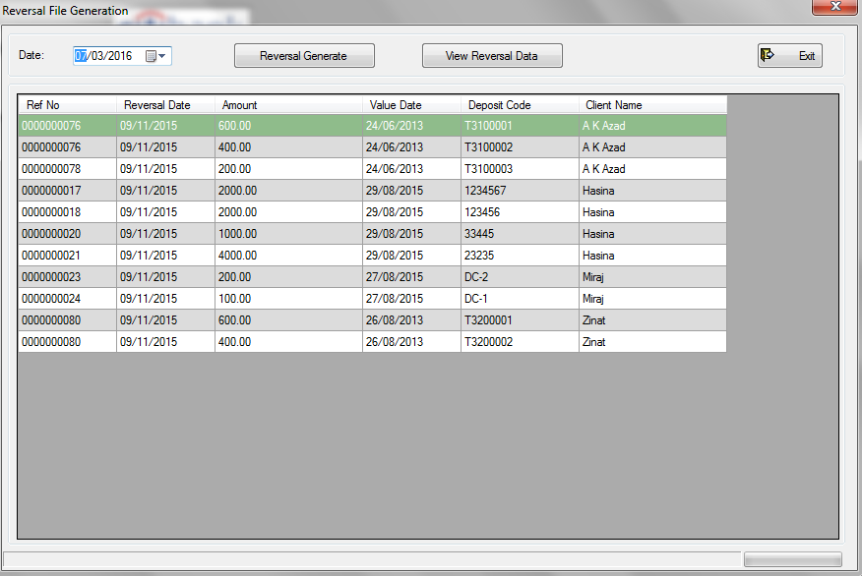

To generate reversal file, select a date and click “Reversal Generate” button.

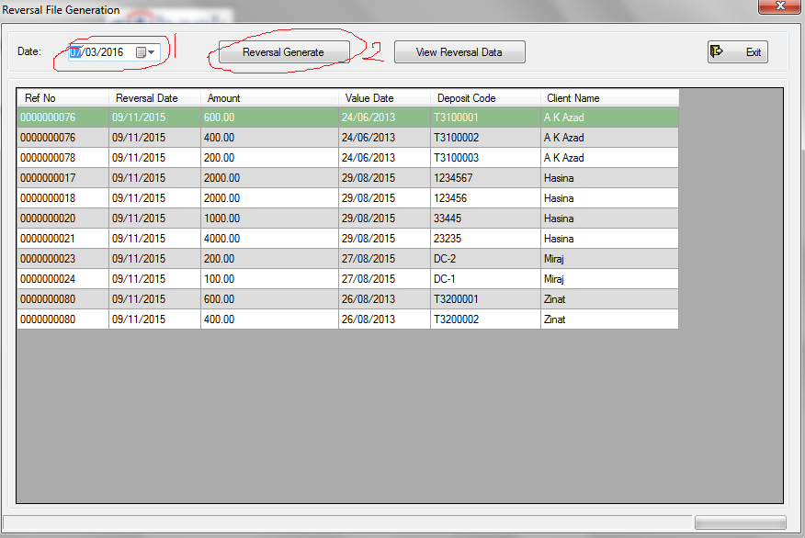

Flex Reversal File: To view and generate reversal data

To view reversal data, click on the “View Reversal Data” button. You will be asked to enter the filename. Enter the filename and click ok to show the reversal data.

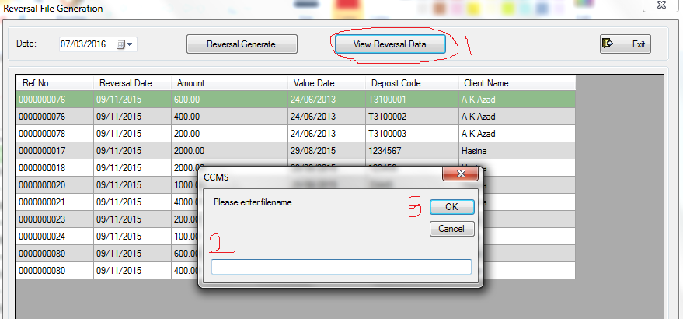

Deposit->Export goAML:

To export data for goAML, go to Deposit->Export goAML. The “Export goAML Data” form will come.

Enter the date from and date to. Enter export location by selecting a folder. Then click export.

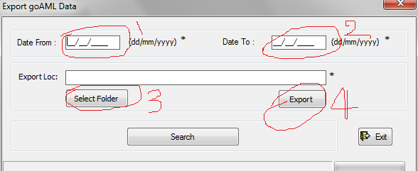

Export goAML: To export data for goAML

4.Collection: Collection Schedule: Detail: To input collection schedule data. Table: DCollected

Summary: to view, edit, and authorize collection schedule data

DD: Detail: To input a DD. Table: DD

Summary: To view, Edit, Authorize DD

CitiSpeed Return: To return a check

CitiSpeed Return File: To generate CitiSpeed return file with return check information

CitiAnyWhere Collection Return: To return CitiAnyWhere check

Guaranteed Credit Booking: To generate Guaranteed Credit Booking file

5. Clearing: Clearing Check: Input, edit, view, authorize check for clearing

Set Clearing Date: To set next clearing date

Upload Clearing Check: To upload clearing checks

Flex File: To generate final file, prepare checking data, view final data, and view checking data

Flex File for Return Checks: To generate Flex file for return

DD Check Process: To pull DD data

Check Return: To return a check, view, edit, authorize returned check

7.Tools:

In Tools, there are 2 menus: 1. PPM Collection, 2. PPM Clearing

To generate PPM collection file(s), go to Tools->PPM Collection. The “PPM Collection File” window will appear.

To generate PPM collection file, select file generation date, and then click on “Generate PPM File”.

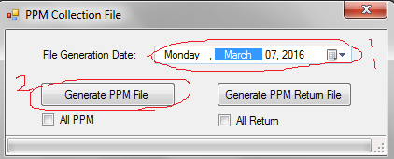

To generate all PPM including previously generated items, check the All PPM option, and click “Generate PPM File”.

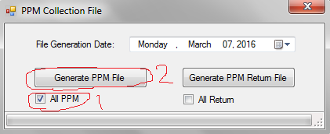

To generate PPM return file, select a file generation date, and click on the “Generate PPM Return File” button.

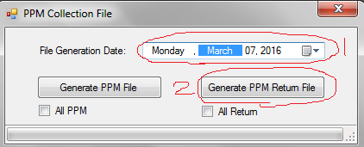

To generate all PPM return file including previously generated return items, check the “All Return” option and click on “Generate PPM Return File”.

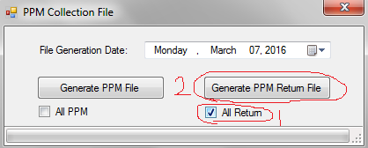

When the process completes generating the file, a status message will be shown to you. Click OK. The generated file location will automatically open.

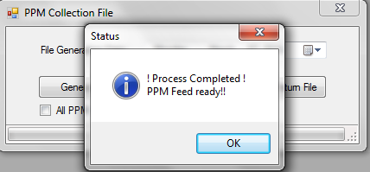

PPM Collection: To generate PPM and PPM return file for PPM from collection

Tools->PPM Clearing:

“PPM Clearing” works in same way as PPM collection.

PPM Clearing: To generate PPM and PPM return file for PPM from clearing

If All PPM or All Return is selected, then all data of PPM will be generated, otherwise data will be generated according to the selected date.

Security in CCMS:

Security is implemented in CCMS in six tiers. These are:

1. Authentication
2. Version Control
3. Authorization
4. Session Management
5. User Activity Monitoring
6. User Inactivity Control

1. Authentication:

When a user tries to login into CCMS, at first he/she should be verified as an authentic user to access CCMS through the authentication system of CCMS.

To authenticate a user, Windows domain-user (Windows-Identity; based on Microsoft NTLM) authentication system is used.

A user can only access the CCMS from a particular Windows with the particular user credentials of that Windows which are enlisted in a particular domain to give access to the user of that domain.

The username is automatically retrieved from the Windows from which the user is accessing the system. User has to enter the password of that particular account to verify his identity.

2. Version Control:

When the user is verified as an authentic user, the version of the software he/she is using to get access the CCMS is checked to verify that if it is an accepted version to get access.

Users can access CCMS with only accepted version(s) of the software.

3. Authorization:

After the version of the software is verified, the user is checked if he/she is authorized to access CCMS.

At first, the existence of the user information in the system is checked. If the user information found, then his/her current status is checked to see that if he/she is enabled to access the system now. A user may be disabled to access the system for his/her inactivity of long time (100 days), or his/her failed attempt of multiple times (more than 4) to access the system with wrong credentials. If he/she wants to access the system again, he/she needs to contact with an administrator of the system.

If the user is able to access the system, his permission to access different menu(s) are checked. A user will get accessed to those menu(s) which he has access.

A user belongs to one or more functional group. Each functional group can access different forms and menus.

When a user tries to access a form, the different permissions of that form for the user is checked, and he/she is given his/her permission to that form.

4. Session Management:

If a user does nothing in the system for more than 30 minutes after login, he/she will be automatically signed out.

[Doing nothing means not doing any input driven action to the system with input devices (e.g.: mouse or keyboard).]

5. User Activity Monitoring:

Important activity of user is monitored and recorded. Admin(s) can view those activity records, and can take legal action against a user if needed.

Important activity includes login, invalid login attempt, logout, adding or removing user, editing user information, adding, removing or editing functional group information, and some other activities.

6. User Inactivity Control:

If a user does not login to the system for more than 100 days, his account will be automatically disabled, and he/she will not be able to access the system anymore.

He/she needs to contact with an administrator if he/she want to access the system again. Only an administrator can change the status (e.g.: from disabled to enabled) of a user.

Create a User:

You have to be an administrator of the system to create a user.

To create a user, go to System-> Users -> Detail. Unlock and click “New”. Enter the user information.

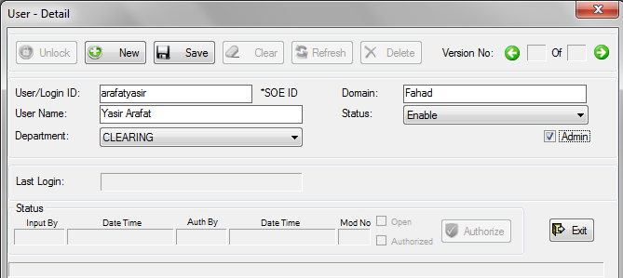

Save the user. This information is needed to be authorized by an author.

Create a Functional Group:

You have to be an administrator of the system to create a Functional Group.

To create a functional group, go to System->Functional Group-> Detail. Unlock and click “New”.

You will see the form list of the system with different permissions.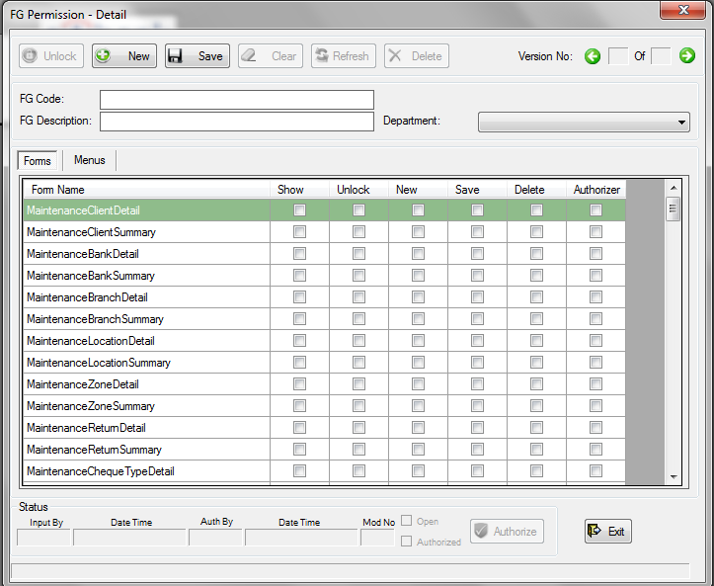

A functional group belongs to a department. Select a department. Enter a functional group code, and a description for the functional group.

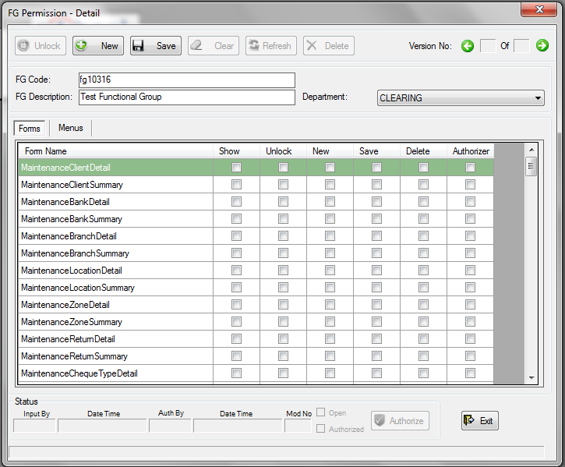

To give permission to a form, just select the checkbox of that permission of that particular form. Suppose, we want to allow the users of this “Test Functional Group” to show, unlock, insert new, and save the client. We know that the form “Client Detail” is in Maintenance->Client->Detail is. So, we will select the “Show”,”Unlock”,”New”, and “Save” checkboxes of the “MaintenanceClientDetail” form.

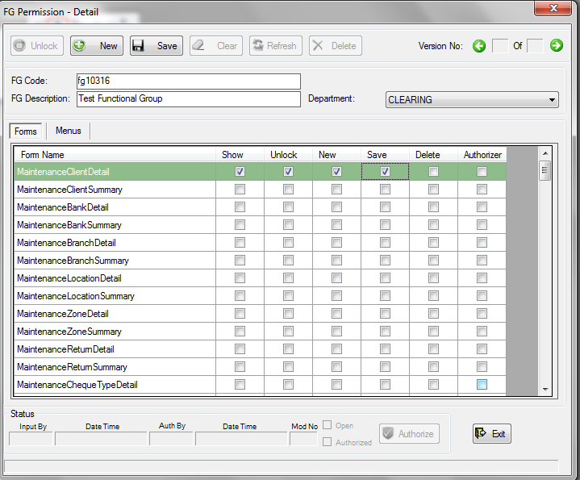

To access the form “Client Detail”, we have to give the functional group some menu permission.

To view the menu permissions list just click on the “Menus” tab at the top of the list. The menu list with menu permissions will appear in the list.

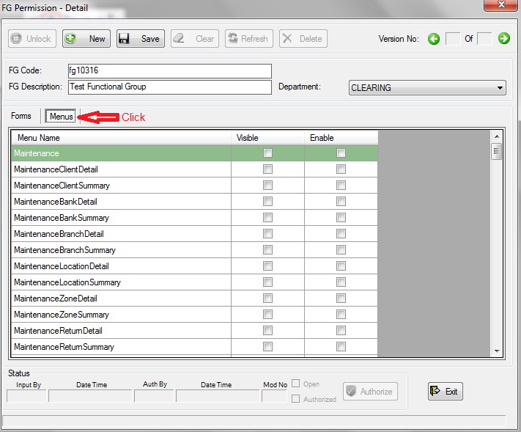

As the form “Client Detail” is in Maintenance->Client->Detail, we have to give permissions to two menus: Maintenance, MaintenanceClientDetail. The user should be able to see and use this menus to access the form. So, we will select “Visible” and “Enable” option of these menus.

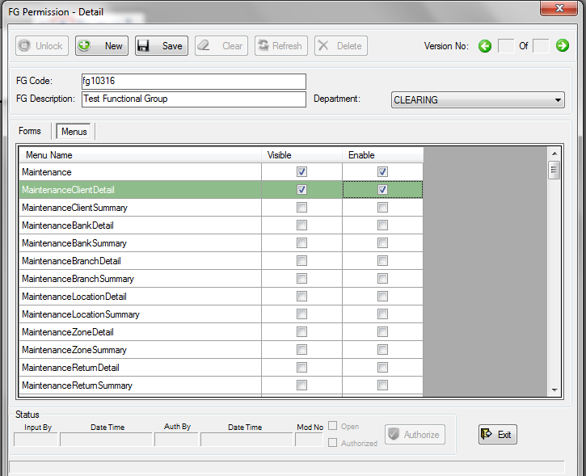

Now save the functional group. It needs to be authorized for use.

Functional group(s) need to be assigned to user(s) to give them permission to forms and menus.

To assign functional group(s) to user(s) go to System-> Assign FG to User-> Detail. (You need to be an administrator to access this menu). Unlock and click “New”. The “User-FG Detail” form will come.

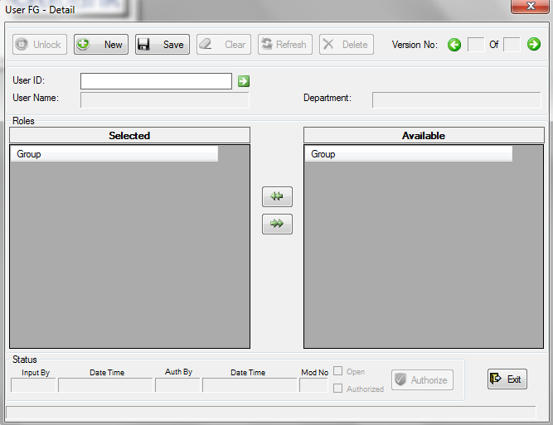

Enter the User ID and press Enter. The user information and available functional group(s) will be loaded to the form.

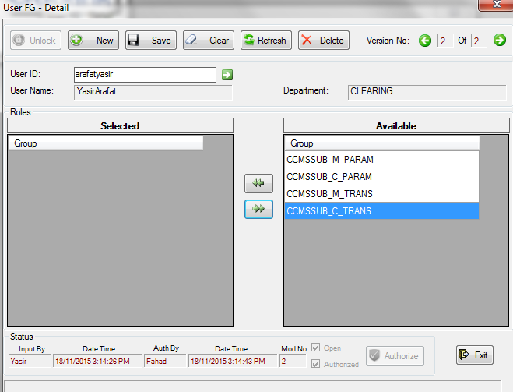

As you can see that there are four functional groups available for this user to be selected. To assign a functional group, just click on the functional group and click the left double arrow.

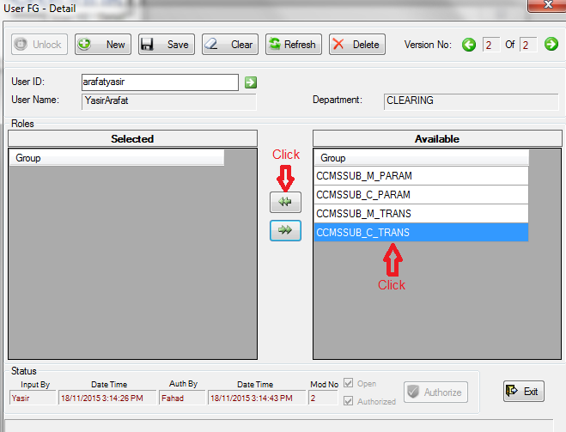

The functional group will go to the selected list from the available list.

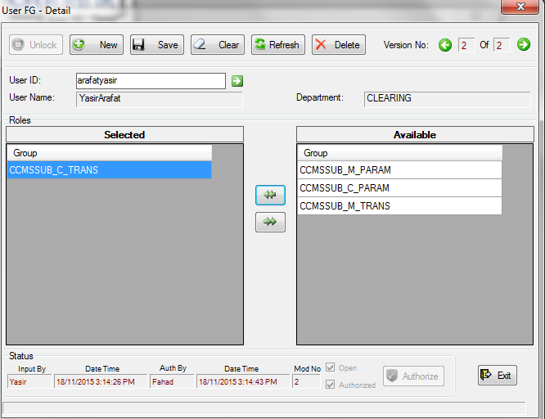

You can assign multiple functional groups to a user by following the same process.

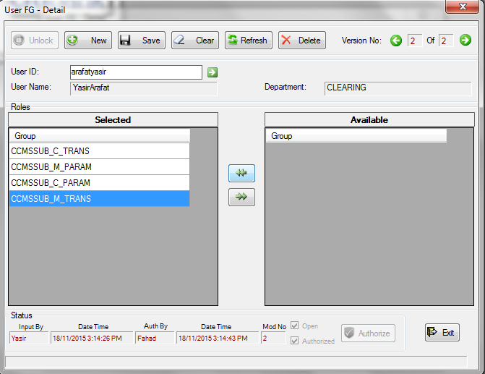

We have selected all the available functional groups for this user.

Now, if want to remove a functional group from the user, we have to click on the functional group at selected list and then click on the right double arrow.

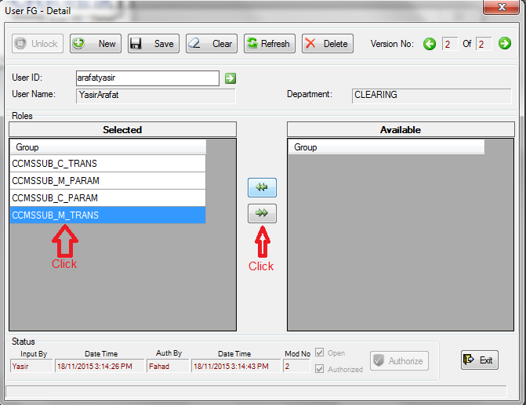

The functional group will go to the available list from the selected list.

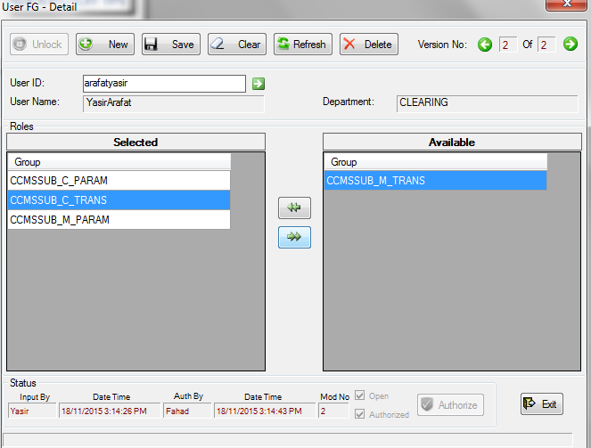

Now, save the information after assigning the functional groups.

To edit existing user permission, go to System->Assign FG User-> Summary.

You will find the user(s) in the system.

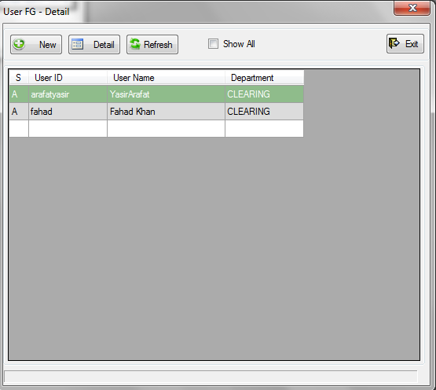

Double click on a user row, or click “Detail” by selecting the user row to open the user information with “User –FG Detail” form. The functional groups in the system will appear to select for this user. Unlock to make any change. Follow the same previous process to change permissions.

To change a user’s status, or change any information of a user, go to System->Users-> Summary. Click “Refresh” if the users list does not comes instantly.

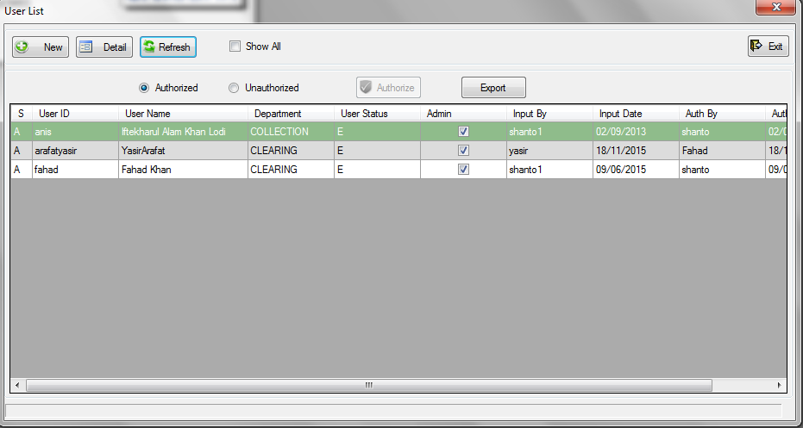

Double click a user row or click “Detail” by selecting the user row to open the user information with “User – Detail” form. Unlock to make any change(s).

